Christ the King Fellowship Presbyterian Church
April 12th, 2020 - 11AM

(10:45AM) Greet each other as we gather -- this is worship too!

Welcome

Psalm 22:1-2 “My God, my God, why have you forsaken me? Why are you so far from saving me, from the words of my groaning? O my God, I cry by day, but you do not answer, and by night, but I find no rest.”

Music “Were You There” as offered by Dave

Prayer of Confession: God please forgive me...
silent prayer & reflection (let the Holy Spirit bring to mind any sin that needs to be confessed - offer it to God & let it go)

Assurance of Pardon & a Call to Worship!
Christ is risen! He is risen indeed!
Music “Because He Lives”

Scripture: John 20:1-18

(And a {maybe longer…} thought)

Music: “Jesus Christ is Risen Today!” (vs. 1-2)
Prayers of the Pastor & the People
With Praises & Thanksgivings
“unmute” & share briefly names & situations & praises too, to lift to God in prayer -- we know God is more than able to hold all we offer & God knows all the details!
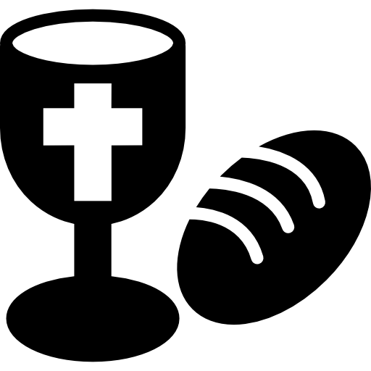
Lord in Your mercy...Hear our prayer.

Communion (see “Communion Liturgy” below)

Offering: we are so blessed, so favored - think of the offering you can gift to God today with great joy!

*music offered by Ann, “Darkness to Light”, based on 1 Peter 2:9*
(if offering a financial gift please send either to: 939 S. Danby Rd, Spencer NY 14883 -OR- PO Box 367, Spencer NY 14883)
Blessing

Singing: “Halle, Halle, Halle-lujah! (X3)
Hallelujah, Hal-le-lu-jah!
Postlude: “Hallelujah Chorus” rendition as offered by Dave

Because He Lives
*Gloria Gaither & William J. Gaither - Praise! Hymnal #238

(chorus) Because He lives I can face tomorrow,
Because He lives all fear is gone;
Because I know He holds the future
And life is worth the living-- just because He lives.

(vs.1) God sent His Son-- they called him Jesus,
He came to love, heal and forgive;
He lived and died to buy my pardon,
An empty grave is there to prove my Savior lives.

(vs.2) How sweet to hold a newborn baby
And feel the pride and joy he gives;
But greater still the calm assurance:
This child can face uncertain days because Christ lives.

(vs.3) And then one day I’ll cross the river,
I’ll fight life’s final war with pain;
And then, as death gives way to victory,
I’ll see the lights of glory-- and I’ll know He lives.

Jesus Christ Is Risen Today (vs. 1-2)
*Stanzas 1-3 Lyra Davidica, 1708, adopted from The Compleat Psalmodist 1749 - Presbyterian Hymnal #123

Jesus Christ is risen today, Alleluia!
Our triumphant holy day, Alleluia!
Who did one upon the cross, Alleluia!
Suffer to redeem our loss, Alleluia!

Hymns of praise then let us sing, Alleluia!
Unto Christ, our heavenly King, Alleluia!
Who endured the cross and grave, Alleluia!
Sinners to redeem and save, Alleluia!

Personal Milestones:
April 15 - Ruth Warner, Gianni Maratea, Jacinto Maratea
April 16 - Jean Schanbacher

Prayer Concerns:

Prayer person: Faye Crance
Prayer young person: Ethan Drake
Prayer theme for young adults: friends
All medical professionals, emergency responders & those serving in hospitals
Military folks & family
S-VE School Board members, administrators, teachers & others
North Spencer Christian Academy
Church Finances
Empowering Lives
St. Paul’s Lutheran Church - Pastor Barb Blom

Communion Liturgy:

Eat this Bread
*Communaute de Taize, adapted by Robert J. Batastini (1984)

Eat this bread, drink this cup,
Come to me and never be hungry.
Eat this bread, drink this cup,
Trust in me and you will not thirst.

The LORD be with you. And also with you.
Lift up your hearts. We lift them to the LORD.
Let us give thanks to the LORD our God.
It is right to give our thanks and praise!

(prayer of thanksgiving & praise -- ending with the LORD's prayer)

...he took bread & after giving thanks to God he broke it & gave it to his disciples saying, "Take, eat. This is my body given for you. Do this in remembrance of me."
And in the same way Jesus took the cup, saying:
"This cup is the new covenant sealed in my blood, shed for you for the forgiveness of sins. Whenever you drink it, do this in remembrance of me."

All who trust in Jesus Christ as Lord are welcome. As you receive the sacrament of communion consider the grace of what Jesus Christ has done for all and how much God loves you. After all have received, let us pray:
Eternal God, You have graciously accepted us as living members of Your Son our Savior Jesus Christ, and You have fed us with spiritual food in the Sacrament of his body and blood. Send us now into the world in peace, and grant us strength and courage to love and serve You with gladness and singleness of heart; through Christ our Lord.

Offering Music Lyrics, “Darkness to Light”:

I will turn your darkness to light.
By my brightness you’ll be led.
I have heard your cry in the night.
Do not fear to step ahead.
I will be a light to your path.
I’ll make the crooked places straight,
And even through the blackest night,
I’ll turn your darkness into light.

