Christ the King Fellowship Presbyterian Church
May10th, 2020 - 11AM
#love

(10:45AM) Greet each other as we gather -- this is worship too!

(11AM) Welcome & Prelude by Dave (“Take My Life”)
Welcome

Call to Worship:
Christ is risen! He is risen indeed!

Singing: “Take My Life”
Confession: God, please forgive me...
silent prayer & reflection (let the Holy Spirit bring to mind any sin that needs to be confessed - offer it to God & let it go)
Assurance of Pardon

Scripture: Acts 7:55-60

(And a few thoughts)

Offering: We are invited to respond to God’s love in joy.

please mail financial gifts to:
939 S. Danby Rd, Spencer NY 14883 -OR- PO Box 367, Spencer, NY. 14883
*praise music by Ann, “In His Time” by Ball
In His time, in His time;
He makes all things beautiful in His time.
Lord, please show me every day
As You’re teaching me Your way,
That You do just what You say in Your time.

In Your time, in Your time;
You make all things beautiful in Your time.
Lord, my life to You I bring;
May each song I have to sing
Be to You a lovely thing in Your time.

Prayers of the Pastor & the People
With Praise & Thanksgiving

“unmute” & share briefly names & situations to lift to God in prayer -- we know God is more than able to hold all we offer & God knows the details!
Lord in Your mercy...Hear our prayer.
Blessing
Singing: “Halle, Halle, Halle-lujah! (X3)
Hallelujah, Hal-le-lu-jah!

Take My Life
*Frances Ridley Havergal, 1874 -- H.A. César Malan, 1827 - Presbyterian Hymnal #391

(vs. 1) Take my life, and let it be
Consecrated, Lord, to Thee.
Take my moments and my days;
Let them flow in ceaseless praise,
Let them flow in ceaseless praise.

(vs.2) Take my hands, and let them move
At the impulse of Thy love.
Take my feet, and let them be
Swift and beautiful for Thee,
Swift and beautiful for Thee.

(vs.5) Take my will, and make it Thine;
It shall be no longer mine.
Take my heart, it is Thine own;
It shall be Thy royal throne,
It shall be Thy royal throne.

Personal Milestones:
May 14 - Ann Weber

Prayer Concerns:

Prayer family: Jennie & James Drake
Prayer young person: Erzsi Helmetsie
Prayer theme for young adults: faith
All medical professionals, emergency responders & those serving in hospitals, nursing homes & care facilities
Military folks & family
S-VE School Board members, administrators, teachers & others
North Spencer Christian Academy
Church Finances
Renovation House
VE Assembly of God - Pastor Don Early

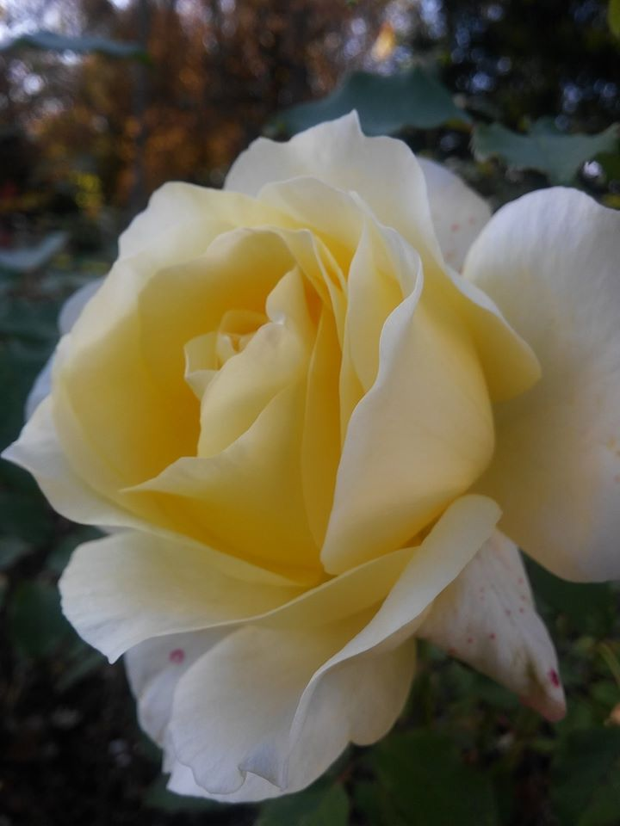
Mother’s Day, can be hard & complicated for most at any time & esp. this year. A rose is perhaps a fitting flower to gift in thinking of Moms...beautiful, layered, sweet & strong (thorns can be necessary to have & Moms also have some thorny kids too!)...We thank God for the Moms of our life -- those who give us life (in so many ways). And we pray comfort for all the complicated, big & hard feelings we feel -- including intense joy & grief. We ask God’s blessing on all this Mother’s Day in the exact way we all need. In Jesus’ Name - Amen.

