
Christ the King Fellowship Presbyterian Church
May 3rd, 2020 - 11AM
#love

(10:45AM) Greet each other as we gather -- this is worship too!

(11AM) Welcome & Prelude by Dave (“Let us Break Bread Together”)

Welcome


Call to Worship:
Christ is risen! He is risen indeed!


Singing: “I Love to Tell the Story”

Confession: God, please forgive me...
silent prayer & reflection (let the Holy Spirit bring to mind any sin that needs to be confessed - offer it to God & let it go)
Assurance of Pardon


Scripture: Acts 2:42-47

(And a few thoughts)


Communion (see “Communion Liturgy” below)

Offering: We are invited to respond to God’s love in joy.
What would you gift God today?

please mail financial gifts either to:
939 S. Danby Rd, Spencer NY 14883 -OR- PO Box 367, Spencer, NY. 14883
*praise music by Ann, “Thank You Lord for saving my soul” by Seth/Bessie Sykes
Thank You Lord for saving my soul
Thank You Lord for making me whole
Thank You Lord for giving to me
Thy great salvation so rich and free


Prayers of the Pastor & the People
With Praise & Thanksgiving

“unmute” & share briefly names & situations to lift to God in prayer -- we know God is more than able to hold all we offer & God knows the details!
Lord in Your mercy...Hear our prayer.
Blessing

Singing: “Halle, Halle, Halle-lujah! (X3)
Hallelujah, Hal-le-lu-jah!

I Love to Tell the Story
*A. Catherine Hankey -- William G. Fischer - Praise! Hymnal #516

(chorus) I love to tell the story!
‘Twill be my theme in glory--
To tell the old, old story
Of Jesus and His love.

(vs.1) I love to tell the story of unseen things above,
Of Jesus and His glory, of Jesus and His love;
I love to tell the story because I know ‘tis true,
It satisfies my longings as nothing else can do.

(vs.2) I love to tell the story--’tis pleasant to repeat
What seems, each time I tell it, more wonderfully sweet;
I love to tell the story, for some have never heard
The message of salvation from God’s own holy Word.

(vs.3) I love to tell the story, for those who know it best
Seem hungering and thirsting to hear it like the rest;
And when in scenes of glory I sing the new, new song,
‘Twill be the old, old story that I have loved so long.


Personal Milestones:
May 2 - Mabel Hodges
May 8 - Karsen Cooke

Prayer Concerns:

Prayer person: Leah Marx
Prayer young person: Jacob Bailey
Prayer theme for young adults: friends
All medical professionals, emergency responders & those serving in hospitals, nursing homes & care facilities
Military folks & family
S-VE School Board members, administrators, teachers & others
North Spencer Christian Academy
Church Finances
Samaritan’s Purse
Bible Baptist of North Spencer - Pastor Steve Barrows

Communion Liturgy:

Eat this Bread
*Communaute de Taize, adapted by Robert J. Batastini (1984)

Eat this bread, drink this cup,
Come to me and never be hungry.
Eat this bread, drink this cup,
Trust in me and you will not thirst.

The LORD be with you. And also with you.
Lift up your hearts. We lift them to the LORD.
Let us give thanks to the LORD our God.
It is right to give our thanks and praise!

(prayer of thanksgiving & praise -- ending with the LORD's prayer)

...he took bread & after giving thanks to God he broke it & gave it to his disciples saying, "Take, eat. This is my body given for you. Do this in remembrance of me."
And in the same way Jesus took the cup, saying:
"This cup is the new covenant sealed in my blood, shed for you for the forgiveness of sins. Whenever you drink it, do this in remembrance of me."

All who trust in Jesus Christ as Lord are welcome (& always have been!). As you receive the sacrament of communion consider the grace of what Jesus Christ has done for us all and how much God loves you. After all have received, let us pray:
God, thank You for graciously accepting us as living members of Your Son our Savior Jesus Christ. Thank you for feeding us with spiritual food in the Sacrament of his body and blood. Send us into the world in peace, and grant us strength and courage to love and serve You with gladness and singleness of heart; through Christ our Lord. Amen. (3-fold Amen, Sung)

Psalm 23, King James Version:
The Lord is my shepherd; I shall not want.
He maketh me to lie down in green pastures: he leadeth me beside the still waters.
He restoreth my soul: he leadeth me in the paths of righteousness for his name's sake.
Yea, though I walk through the valley of the shadow of death, I will fear no evil: for thou art with me; thy rod and thy staff they comfort me.
Thou preparest a table before me in the presence of mine enemies: thou anointest my head with oil; my cup runneth over.
Surely goodness and mercy shall follow me all the days of my life: and I will dwell in the house of the Lord for ever.

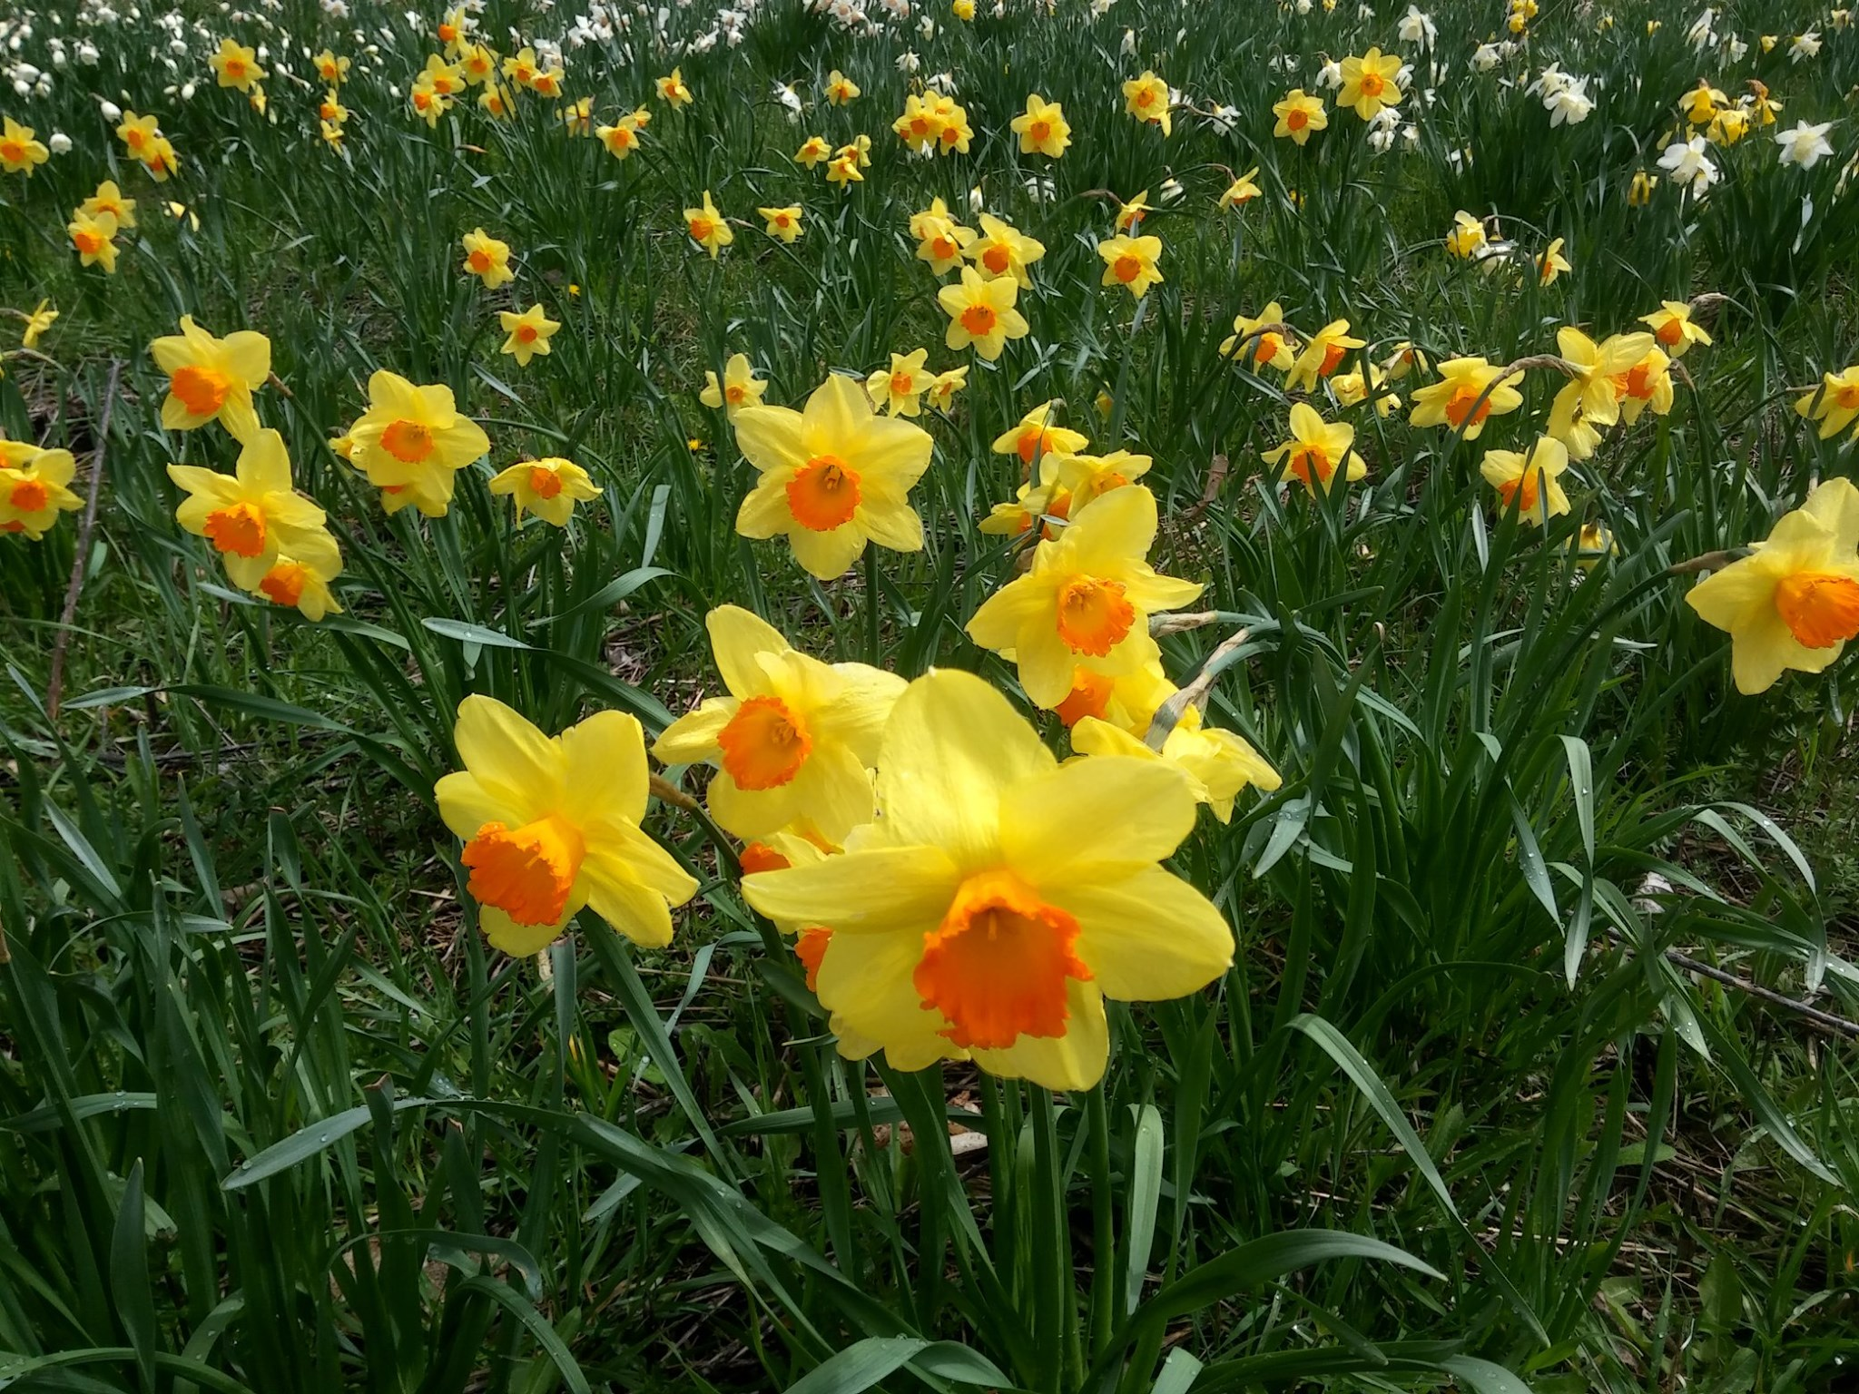
(what’s your green pasture look like today?...)

