Christ the King Fellowship Presbyterian Church
July 5th, 2020 - 10AM
#love

Welcome & Prelude by Dave (Variations on America)
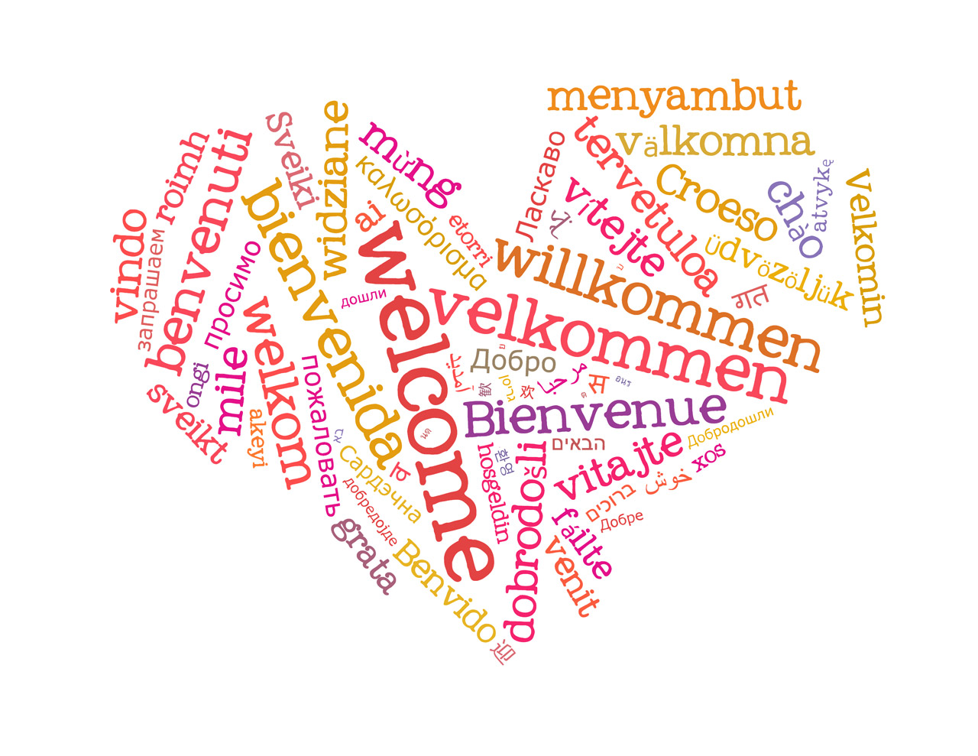
Welcome

Call to Worship (Psalm 118:24):
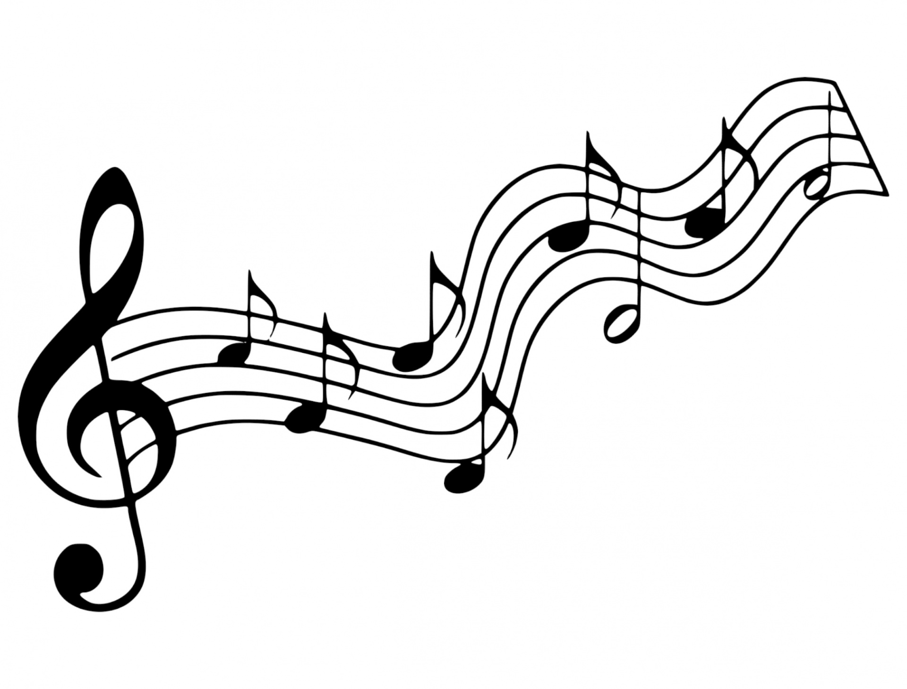
This is the day that the Lord has made! We will rejoice & be glad in it!

Music (Cantor)
“Joyful, Joyful, We Adore Thee”

Confession: God, please forgive me...
silent prayer & reflection (let the Holy Spirit bring to mind any sin that needs to be confessed - offer it to God & let it go)

Assurance of Pardon
Glory be to the Father, and to the Son, and to the Holy Ghost! Thank You God for grace! Amen!

Scripture: Matthew 11:25-30

(Kid’s Time & Sermon Thoughts)
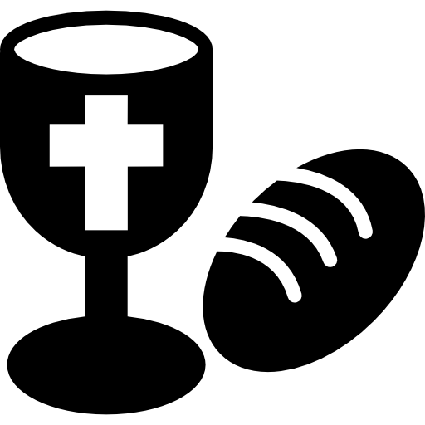
Communion (see “Communion Liturgy” below)

Offering: We respond to God’s love in joy.
please drop financial gifts when arriving/leaving or mail to:
939 S. Danby Rd, Spencer NY 14883 -OR- PO Box 367, Spencer, NY. 14883

Responsive Organ Music - “Let Us Break Bread Together”

Prayers of the Pastor & the People
With Praise & Thanksgiving

share briefly names & situations to lift to God in prayer -- we know God is more than able to hold all we offer & God knows the details!
Lord in Your mercy...Hear our prayer.
Blessing

Instruments: “Halle, Halle, Halle-lujah! (X3)
Hallelujah, Hal-le-lu-jah!

Postlude: “God of Our Fathers”

Joyful, Joyful, We Adore Thee (Presbyterian Hymnal #464)
Henry van Dyke, 1907; alt. Ludwig van Beethoven, 1824. Adapt. Edward Hodges (1796-1867); alt.

Joyful, joyful, we adore Thee, God of glory, Lord of love;
Hearts unfold like flowers before Thee, Opening to the sun above. Melt the clouds of sin and sadness; Drive the gloom of doubt away;
Giver of immortal gladness, Fill us with the light of day.

All Thy works with joy surround Thee, Earth and heaven reflect Thy rays, Stars and angels sing around Thee, Center of unbroken praise. Field and forest, vale and mountain, Flowery meadow, flashing sea,
Chanting bird and flowing fountain, Call us to rejoice in Thee.

Mortals, join the happy chorus Which the morning stars began;
Love divine is reigning o’er us, Joining all in heaven’s plan.
Ever singing, march we onward, Victors in the midst of strife,
Joyful music leads us sunward In the triumph song of life.

Personal Milestones:
July 14: Sally Marx
July 19: Rick & Rebecca Dann

Prayer Concerns:
Prayer family: Ralph & Ellie Cobb
Prayer young person: Erzsi Helmetsie
Prayer theme for young adults: faith
All medical professionals, emergency responders & those serving in hospitals, nursing homes & care facilities
Military folks & family
S-VE School Board members, administrators, teachers & others
North Spencer Christian Academy
Church Finances
Empowering Lives
Halsey Valley UMC - Pastor Dick VanDerpoel

Communion Liturgy:

Eat this Bread (Cantor voice)
*Communaute de Taize, adapted by Robert J. Batastini (1984)
Eat this bread, drink this cup,
Come to me and never be hungry.
Eat this bread, drink this cup,
Trust in me and you will not thirst.

The LORD be with you. And also with you.
Lift up your hearts. We lift them to the LORD.
Let us give thanks to the LORD our God.
It is right to give our thanks and praise!

(prayer of thanksgiving & praise -- ending with the LORD's prayer)

...he took bread & after giving thanks to God he broke it & gave it to his disciples saying, "Take, eat. This is my body given for you. Do this in remembrance of me."
And in the same way Jesus took the cup, saying:
"This cup is the new covenant sealed in my blood, shed for you for the forgiveness of sins. Whenever you drink it, do this in remembrance of me."

All who trust in Jesus Christ as Lord are welcome (& always have been!). As you receive the sacrament of communion consider the grace of what Jesus Christ has done for us all and how much God loves you. After all have received, let us pray:
God, thank You for graciously accepting us as living members of Your Son our Savior Jesus Christ. Thank you for feeding us with spiritual food in the Sacrament of his body and blood. Send us into the world in peace, and grant us strength and courage to love and serve You with gladness and singleness of heart; through Christ our Lord. Amen. Amen. Amen!

