Christ the King Fellowship Presbyterian Church
August 2nd, 2020 - 10AM
#love

Welcome & Prelude by Jacob Dove (“Prelude in F” by J. S. Bach)
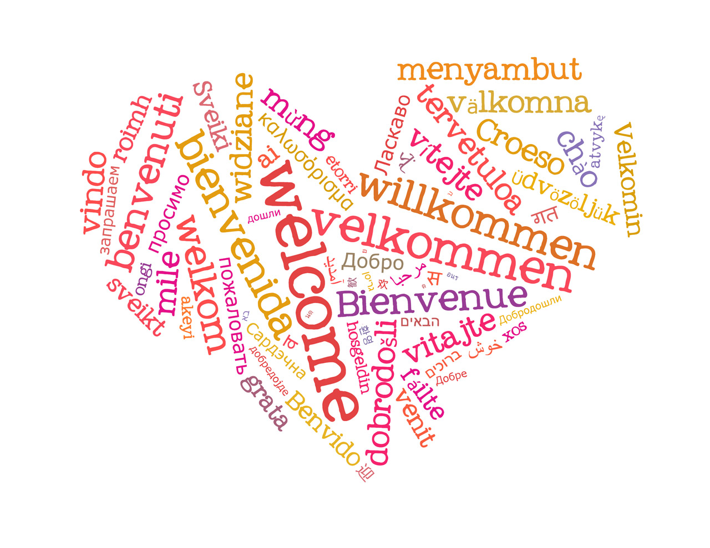
Welcome

Call to Worship (Psalm 118:24):
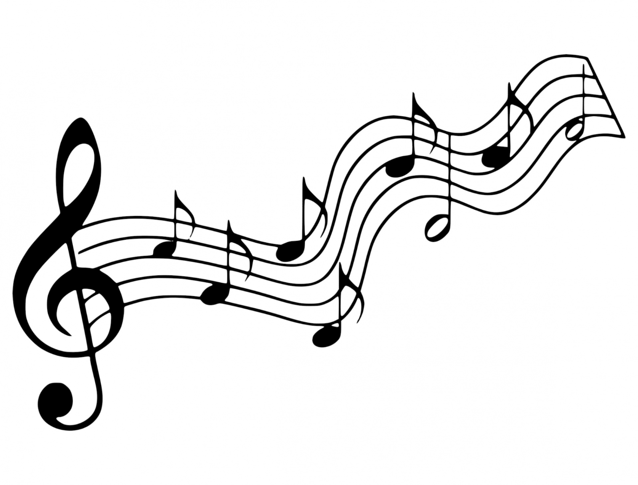
This is the day that the Lord has made! We will rejoice & be glad in it!

Music (Cantor)
“My Hope Is Built on Nothing Less”
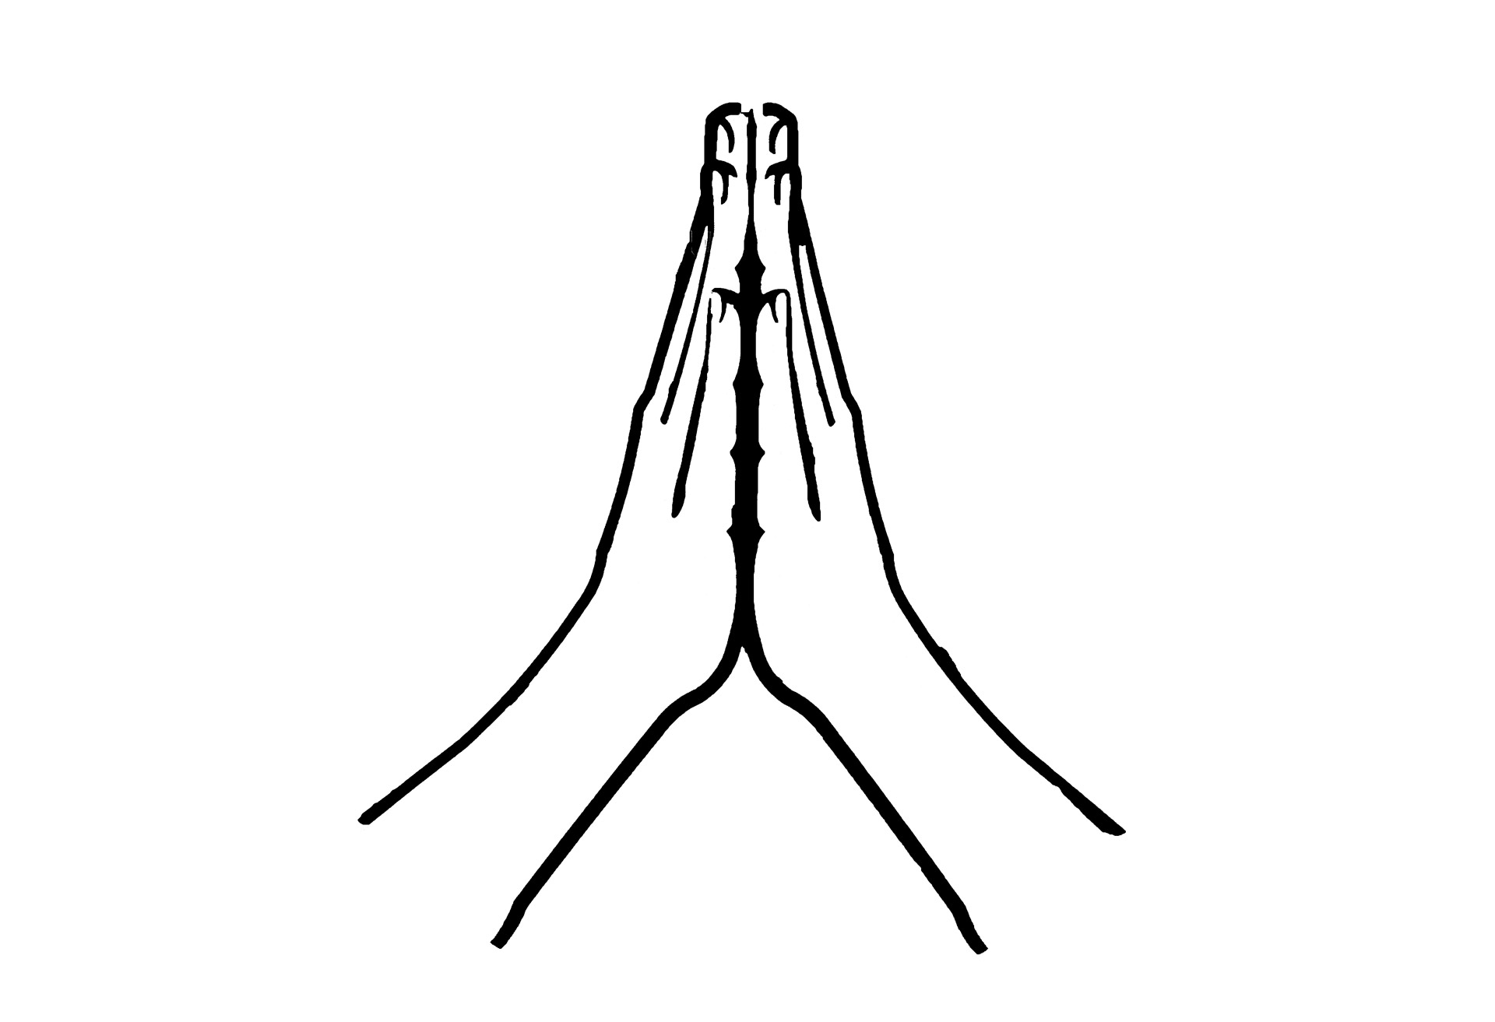
Confession: God, please forgive me...
silent prayer & reflection (let the Holy Spirit bring to mind any sin that needs to be confessed - offer it to God & let it go)

Assurance of Pardon
Glory be to the Father, & to the Son & to the Holy Ghost! Thank You God for grace! Amen!

Scripture: Romans 8:28-30
(Kid’s Time & Sermon
Thoughts)
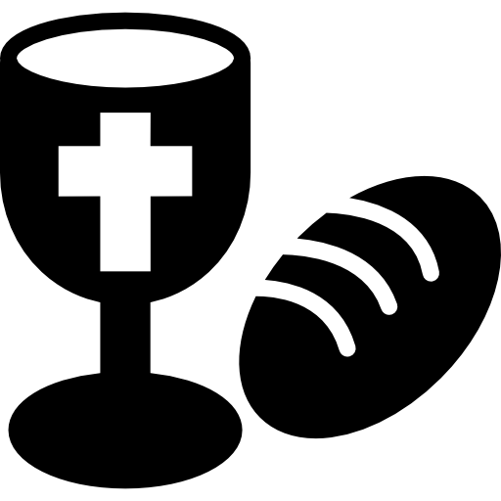

Communion (see “Communion Liturgy” below)

Offering: We respond to God’s love in joy.
please drop financial gifts when arriving/leaving or mail to:
939 S. Danby Rd, Spencer NY 14883 -OR- PO Box 367, Spencer, NY. 14883

Responsive Organ Music
“Trumpet Tune” arr. Henry Purcell, played by

Prayers of the Pastor & the People
With Praise & Thanksgiving

share briefly names & situations to lift to God in prayer -- we know God is more than able to hold all we offer & God knows the details!
Lord in Your mercy...Hear our prayer.
Blessing

Instruments: “Halle, Halle, Halle-lujah! (X3)
Hallelujah, Hal-le-lu-jah!

Postlude “All People That on Earth Do Dwell” (Presbyterian Hymnal #220)
William Kethe, 1560 - Attr. Louis Bourgeois (c.1510-c.1561)

My Hope Is Built on Nothing Less
Edward Mote, c.1834; William Batchelder Bradbury, 1863. Presbyterian Hymnal (#379)

(Vs.1) My hope is built on nothing less Than Jesus’ blood and righteousness; I dare not trust the sweetest frame, But wholly lean on Jesus’ Name.

(Refrain) On Christ, the solid Rock, I stand; All other ground is sinking sand, All other ground is sinking sand.

(Vs.2) When darkness veils His lovely face, I rest on His unchanging grace; In every high and stormy gale, My anchor holds within the veil.

(Vs.3) His orat, His covenant, His blood Support me in the whelming flood; When all around my soul gives way, He then is all my hope and stay.

(Vs.4) When He shall come with trumpet sound, O may I then in Him be found, Dressed in His righteousness alone, Faultless to stand before the throne.

Personal Milestones:
July 31: Yoko von Borstel

Prayer Concerns:
Prayer person: David Lanning
Prayer young person: Aurora Dann
Prayer theme for young adults: faith
All medical professionals, emergency responders & those serving in hospitals, nursing homes & care facilities
Military folks & family
S-VE School Board members, administrators, teachers & others
North Spencer Christian Academy
Church Finances
Samaritan’s Purse
First Baptist of West Danby - Pastor Seth Finch

Communion Liturgy:
Eat this Bread (Cantor voice)
*Communaute de Taize, adapted by Robert J. Batastini (1984)
Eat this bread, drink this cup, Come to me and never be hungry. Eat this bread, drink this cup, Trust in me and you will not thirst.
The LORD be with you. And also with you. Lift up your hearts. We lift them to the LORD. Let us give thanks to the LORD our God. It is right to give our thanks and praise!
(prayer of thanksgiving & praise -- ending with the LORD's prayer)
...he took bread & after giving thanks to God he broke it & gave it to his disciples saying, "Take, eat. This is my body given for you. Do this in remembrance of me." And in the same way Jesus took the cup, saying: "This cup is the new covenant sealed in my blood, shed for you for the forgiveness of sins. Whenever you drink it, do this in remembrance of me."
All who trust in Jesus Christ as Lord are welcome (& always have been!). As you receive the sacrament of communion consider the grace of what Jesus Christ has done for us all and how much God loves you. After all have received, let us pray:
God, thank You for graciously accepting us as living members of Your Son our Savior Jesus Christ. Thank you for feeding us with spiritual food in the Sacrament of his body and blood. Send us into the world in peace, and grant us strength and courage to love and serve You with gladness and singleness of heart; through Christ our Lord. Amen. Amen. Amen!

