Glory be to the Father, & to the Son, & to the Holy Ghost! As it was in the beginning, is now and ever shall be. World without end. Amen, Amen.

Praise: “Come Share The Lord”

Scripture: James 2:1-17

Faith Engagement & Sermon
“Let Us Break Bread Together”
(Red Praise No. 162)

Communion (see “Communion Liturgy” below)

Offering: We respond to God’s love in joy.
please drop financial gifts when arriving/leaving or mail to:
939 S. Danby Rd, Spencer NY 14883 -OR- PO Box 367, Spencer, NY. 14883

Doxology
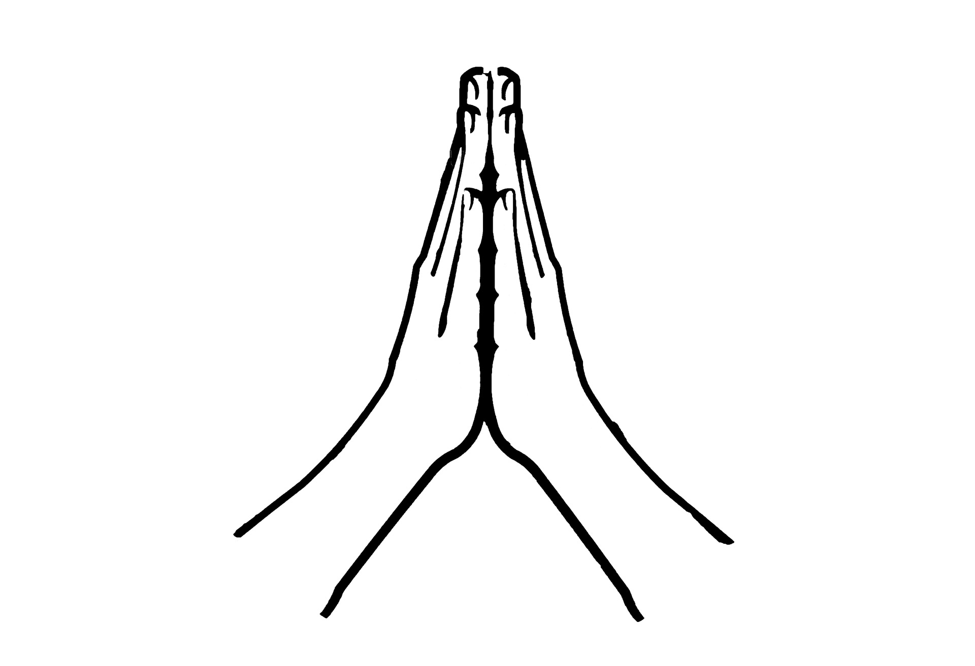

Prayers of the Pastor & the People
With Praise & Thanksgiving

share briefly names & situations to lift to God in prayer -- we know God is more than able to hold all we offer & God knows the details!
Lord in Your mercy...Hosanna!
Blessing

“Halle, Halle, Halle-lujah (X3) Hallelujah, Hal-le-lu-jah!”
Christ the King Fellowship (Presbyterian Church)
September 5, 2021 - 10AM
#love

Prelude: Let Us Break Bread Together (arr. Mark Hayes)

Welcome

Call to Worship (Psalm 34:3,1):
Magnify the Lord with me: Let us exalt God together!
I will bless the LORD at all times; God’s praise shall always be in my mouth!

Music: “Jesu, Jesu, Fill Us with Your Love”
(Blue Hymnal No. 367)
Confession: Almighty God, you love us, but we have not loved you. You call, but we have not listened. We walk away from neighbors in need, wrapped in our own concerns. We condone evil, prejudice, warfare, and greed. God of grace, help us to admit our sin, so that as you come to us in mercy, we may repent, turn to you, and receive forgiveness; through Jesus Christ our redeemer.
silent prayer & reflection: let the Holy Spirit bring to mind any sin that needs to be confessed - offer it to God & let it go
Assurance of Pardon
Music: Gloria Patri

Communion Liturgy:
Eat this Bread *Communaute de Taize, adapted by Robert J. Batastini (1984)

Eat this bread, drink this cup, Come to me and never be hungry. Eat this bread, drink this cup, Trust in me and you will not thirst.
The LORD be with you. And also with you. Lift up your hearts. We lift them to the LORD. Let us give thanks to the LORD our God. It is right to give our thanks and praise!
(prayer of thanksgiving & praise -- ending with the LORD's prayer)

...he took bread & after giving thanks to God he broke it & gave it to his disciples saying, "Take, eat. This is my body given for you.
Do this in remembrance of me."

And in the same way Jesus took the cup, saying:
"This cup is the new covenant sealed in my blood, shed for you for the forgiveness of sins. Whenever you drink it, do this in remembrance of me."

All who trust in Jesus Christ as Lord are welcome. As you receive the sacrament of communion consider the grace of what Jesus has done for us all and how much God loves you. After all receive, we pray:

God, thank You for accepting us as living members of Your Son & our Savior Jesus Christ. Thank you for feeding us with spiritual food in the Sacrament of his body and blood. Send us into the world in peace, granting us strength and courage to love and serve You with gladness and singleness of heart; through Christ our Lord.

3-fold Amen. (Amen, Amen, Amen!)

Come Share The Lord -- Leech

We gather here in Jesus' Name;
His love is burning in our hearts like living flame;
For through the loving son, the Father makes us one.
Come take the bread, come drink the wine,
Come share the Lord.

Notes & Doodles:

Prayer Concerns:
Prayer person: Lisa Beck
Prayer young person: Elliot Bailey
Prayer theme for young adults: general welfare
All medical professionals, emergency responders & those serving
in hospitals, nursing homes & care facilities
Military folks & family - the USA & all those in leadership
S-VE School Board members, administrators, teachers & others
North Spencer Christian Academy -- CTK Church Finances -- Empowering Lives
Faith Bible Chapel - Pastor Andy Windnagel

Announcements/Reminders:
Friday -- 11AM Women's Bible Study
Monday -- No Pastor's Hours
Monday -- 6PM AA
Wednesday -- 11AM Adult Study
Sunday (9/12) -- 10AM Church Brunch & 11AM Worship

- Sept. 12th -- Church BRUNCH @ 10AM - worship @ 11AM (end of Summer Hours)
- Sept. 16th (Thurs) Choir
- Sept. 19th (following worship) connect with Ombudspersons & Session (& anyone with a concern)
- Sept. 19th @ 4PM Organ Concert (w/Mr. David Jackson of course!)
- Sept. 21st @ 10AM next Session Mtg
- Sept. 26th - Renovation House will be joining us for worship
- Sept. 28th (Tuesday) next Presbytery Mtg (on zoom)
- Sunday - Nov. 7th -- date for Congregation to vote on new members to Session & Deacons!

