

Scripture: 1st Scripture: Hebrews 9:24-28

2nd Scripture: Daniel 1



Faith Engagement & Sermon



Music: “I Came With Joy “ vs. 1,2,3,4

(Blue Hymnal No. 507)



Communion (see “Communion Liturgy”)

Offering: *We respond to God’s love in joy.*

please drop financial gifts when arriving/leaving or mail to:

*939 S. Danby Rd, Spencer NY 14883 -OR- PO Box 367, Spencer, NY. 14883*

**Doxology** (Blue #592)



Prayers of the Pastor & the People

With Praise & Thanksgiving

*share briefly names & situations to lift to God in prayer -- we know God is more than able to hold all we offer & God knows the details*

 Lord in your mercy...**Hosanna!**

Blessing

 **“Halle, Halle, Halle-lujah (X3) Hallelujah, Hal-le-lu-jah!”**

Postlude “For All The Saints” (Blue No. 526)

**Prayer Concerns:**

Prayer family: **Ralph and Ellie Cobb**

Prayer young person: **Devin Decker**

Prayer theme for young adults: **general welfare**

All medical professionals, emergency responders & those serving

in hospitals, nursing homes & care facilities

Military folks & family - the USA & all those in leadership

S-VE School Board members, administrators, teachers & others

North Spencer Christian Academy -- CTK Church Finances -- Renovation House

North Van Etten Church

**Announcements/Reminders:**

* **Sunday - Nov. 7th -- date for Congregation to vote on new members to Session & Deacons!**
* **Monday Finance Comm. Meeting 1:00 PM**
* **Wednesday Men’s bible Study 6:00 AM**
* **Adult Bible Study 11:00 AM**
* **Friday Women’s Study 11:00 AM**
* Following Worship next Sunday (Nov. 14th) talk w/Walt, Sally or Session with any concerns.
* **Sunday - Nov. 29th -- church decoration**
* **Sunday - Dec. 17th (@4PM) Remembrance Service** 
  + **Girl Scouts will be back (YAY) 1st Sunday Oct. 3rd -- 1:30-3:30/4PM -- every other week (both lower & upper level @ church)**
  + **Community Thanksgiving Worship Service (yes) & maybe Thanksgiving Dinner - @ Federated Church**
  + **FYIs -- October -- working through Proverbs & Nov looking to have a church fast again**

**Community Events:**

* Mon. 10-11AM Preschool Story Hr @ Spencer Library
* Wed. 4-5:30PM [Open Hearts Dinner @ Mckendree UMC **TAKE OUT ONLY](https://www.candormethodists.com/openheartsdinnermenu)**
* Sat. 6PM 30 West Fellowship of Faith (@ 30 W. Tioga St, Spencer) [INFO](https://docs.google.com/presentation/d/1gSIDLegOBYXijkgk1MtT7Jeih2Hxc-qX37O6fkYDjZw/pub?start=false&loop=false&delayms=3000&slide=id.gedf659102b_1_0)
* Sun. 3PM @ Spencer Federated Church Alpha Program

**Communion Liturgy:**

**Eat this Bread** *Communaute de Taize, adapted by Robert J. Batastini (1984)

*Eat this bread, drink this cup, Come to me and never be hungry. Eat this bread, drink this cup, Trust in me and you will not thirst.*

The LORD be with you. **And also with you.** Lift up your hearts. **We lift them to the LORD.** Let us give thanks to the LORD our God. **It is right to give our thanks and praise!**

(prayer of thanksgiving & praise -- ending with the **LORD's prayer**)

...he took bread & after giving thanks to God he broke it & gave it to his disciples saying, **"Take, eat. This is my body given for you.**

**Do this in remembrance of me."**

And in the same way Jesus took the cup, saying:

**"This cup is the new covenant sealed in my blood, shed for you for the forgiveness of sins. Whenever you drink it, do this in remembrance of me."**

*All who trust in Jesus Christ as Lord are welcome. As you receive the sacrament of communion consider the grace of what Jesus has done for us all and how much God loves you. After all receive, we pray:*

**God, thank You for accepting us as living members of Your Son & our Savior Jesus Christ. Thank you for feeding us with spiritual food in the Sacrament of his body and blood. Send us into the world in peace, granting us strength and courage to love and serve You with gladness and singleness of heart; through Christ our Lord.**

**3-fold Amen. (Amen, Amen, Amen!)**

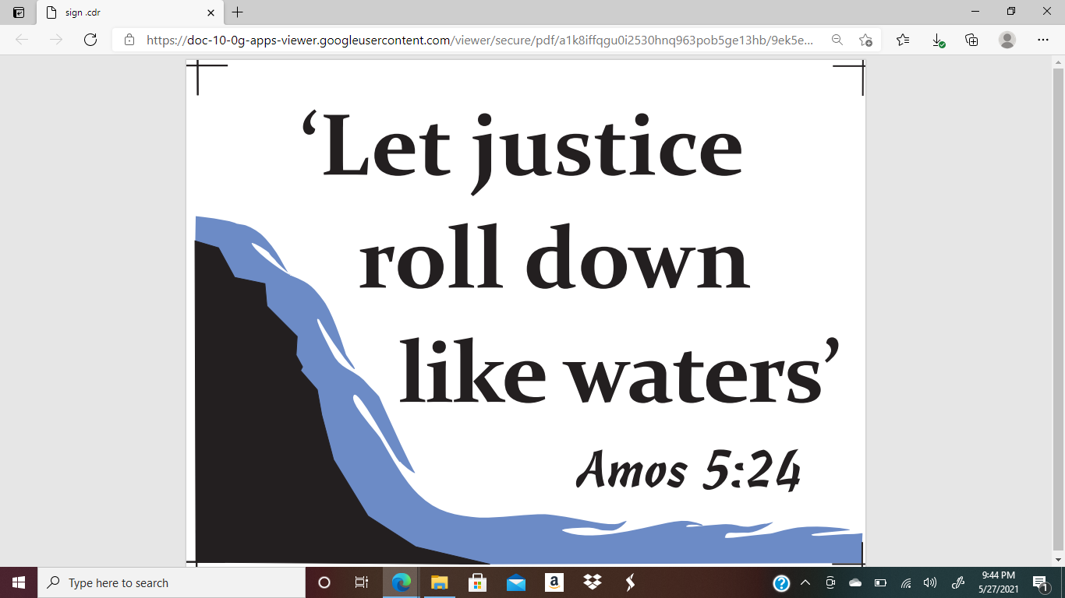

Christ the King Fellowship

Presbyterian

November 7**, 2021 11:00 AM**

**#love**

Prelude “Swing Low Sweet Chariot” arr. Marianne Kim



Welcome

Call to Worship (the Doxology)

**Praise God, from whom all blessings flow; Praise *Him, all creatures here below; Praise *Him above, ye heavenly host; Praise Father, Son, and Holy Ghost. Amen.**

Music: “Jesus Paid It All” vs. 1,2,4

( Red Praise No. 219)

Confession:

**Holy and merciful God, in Your presence we confess our failure to be what You created us to be.  You alone know how often we have sinned in wandering from Your ways, in wasting Your gifts, in forgetting Your love.  By Your loving mercy, help us to live in Your light and abide in Your ways, for the sake of Jesus Christ our Savior.**

*silent prayer & reflection: let the Holy Spirit bring to mind any sin that needs to be confessed - offer it to God & let it go*

Assurance of Pardon

Music: **Gloria Patri (No. 579 Blue Hymnal)**

***Glory be to the Father, & to the Son, & to the Holy Ghost! As it was in the beginning, is now and ever shall be. World without end. Amen, Amen.***