Assurance of Pardon & Gloria Patri (Blue No. 579)

Glory be to the Father, and to the Son, and to the Holy Ghost. As it was in the beginning, is now, and ever shall be, world without end. Amen. Amen.

Praise Songs
King Of Kings Lhu - 48 Unknown
King of kings and Lord of lords,
Glory, (clap) hallelujah!
King of kings and Lord of lords,
Glory, (clap) hallelujah!

Jesus, Prince of Peace, Glory,
(clap) hallelujah!
Jesus, Prince of Peace, Glory,
(clap) hallelujah!

Emmanuel Has Come Sandquist

He laid down His crown, put aside His glory.
He became a baby. He became a man.
He stepped off His throne to obey the Father
To become our brother, first of many sons.
Glory, glory, glory, Emmanuel has come.
Glory, glory, glory, Christ is the firstborn of many sons.

Scripture #1: Zeph. 3:14-20 (p. 1348)
Scripture #2: Isa. 12:2-6 (p.990)
Faith Engagement and Sermon

Music “Joy to the World” (Blue No.40)
The Doxology

Praise God, from whom all blessings flow; Praise *Him, all creatures here below; Praise *Him above, ye heavenly host; Praise Father, Son, and Holy Ghost. Amen.
Prayers of the Pastor & the People
With Praise & Thanksgiving

share briefly names & situations to lift to God in prayer -- we know God is more than able to hold all we offer & God knows the details!
Lord in Your mercy...Hear our prayer!
Blessing “Halle, Halle, Halle-lujah (X3)
Hallelujah, Hal-le-lu-jah!”

Postlude “Lift Up Your Heads” (Blue Hymnal No.8)

Personal Miletones

December 9 – Gina Bailey
December 11- Edna Reynolds
December 12- Joan Cooke
December 15- Emma Drake
December 18 –Sharon Comfort
Prayer Concerns:
Prayer person: Joan Cooke
Prayer young person: Jace Decker
Prayer theme for young adults: school/work
All medical professionals, emergency responders & those serving
in hospitals, nursing homes & care facilities
Military folks & family - the USA & all those in leadership
S-VE School Board members, administrators, teachers & others
North Spencer Christian Academy
Church Finances
Renovation House
North Van Etten church

Announcements/Reminders:
A note about offering - all we have is a gift from God. We are invited weekly (and honestly at all times)to respond to God & joyfully give some of what we’ve been trusted with. For financial giving please place in an offering plate when arriving/leaving or mail to:
- Danby Rd, Spencer NY 14883 -OR- PO Box 367, Spencer, NY. 14883

Calendar
- Sunday -- 4PM Carol Sing featuring Spencer Singers, Walt Baer &
Chip Beckley (masks required)
- Monday -- No Pastor's Hours (Plan/Play day)
- Monday -- 6PM AA
- Wednesday -- 6AM Men's Breakfast & Bible Study
- Wednesday -- 11AM Adult Study
- Wednesday -- 1:30PM Pastor's Mtg
- Friday -- Women's Bible Study
Community Events:
- Wed. 4-5:30PM Open Hearts Dinner @ Mckendree UMC **TAKE OUT ONLY**
- 12/12: 4PM Carol Sing featuring Spencer Singers, Walt Baer & Chip Beckley (mask required in-person)
- 12/13: 10-11AM Preschool Story Hour @ Spencer Library (41 N. Main St, Spencer)
- 12/16: 9-11:30AM SVE Food Cupboard food give-away (Orchard St. near the "old" Dollar General) -- this is the Holiday Give-away -- curb-side pick-up only -- INFO (open to all who live or work in SVE School District)
- 12/17: 4PM "Christmas Magic" @ VE Library - free/open to public/masks required (INFO
Library happenings:
- @ Spencer Library -- Mondays 10AM-11AM Preschool Reading Hour
- @ Van Etten Library -- Take & Make Kits - leaf lanterns! Call 607-589-4435 ext.3 to arrange for pick up of your kit.

Christ the King Fellowship
Presbyterian #love
December 12, 2021 - 11 AM
Welcome
Prelude: “Joy! Joy! Joy!” arr. Mark Hayes

Call to Worship (Psalm 39:7 & “O Come, O Come, Emmanuel”)
And now, O LORD, what do I wait for? My hope is in You.
♪ O come, Thou Day-spring, come and cheer Our spirits by Thine advent here; Disperse the gloomy clouds of night, And death's dark shadows put to flight.

Advent Candle Lighting: Joy. (prayer: Book of Common Worship)

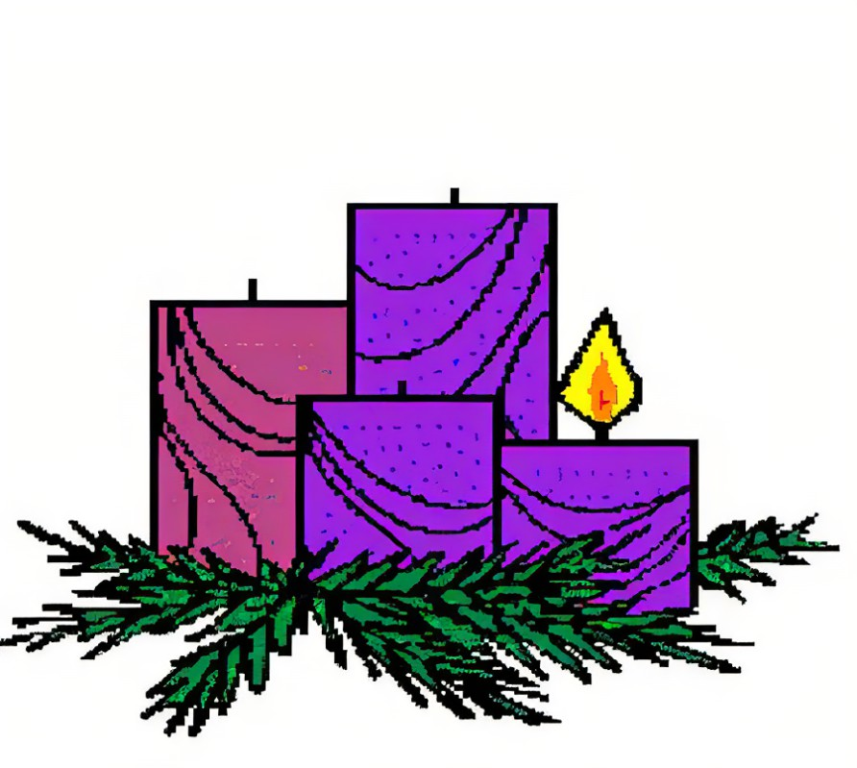
*AFTER the candle has been lit:

Almighty God, You have made us and all things to serve You. Now prepare the world for Your rule. Come quickly to save us, so that wars and violence shall end, and Your children may live in peace, honoring one another with justice and love; through Jesus Christ, who lives and reigns with You in the unity of the Holy Spirit, one God, now and forever. Amen
Music “Lift Up Your Heads, Ye Mighty Gates ”
(Blue Hymnal No. 8)

Confession:
Holy and merciful God, in Your presence we confess our failure to be what You created us to be. You alone know how often we have sinned in wandering from Your ways, in wasting Your gifts, in forgetting Your love. By Your loving mercy, help us to live in Your light and abide in Your ways, for the sake of Jesus Christ our Savior.

[silent prayer & reflection; let the Holy Spirit identify any sin that needs confessing - offer it to God & let it go]

