Scripture 1: 1 Corinthians 13:1-13 (p.1637)
Scripture 2: Jeremiah 1:4-10 (p.1075)

Faith Engagement and Sermon
“Here I Am, Lord “
Blue Hymnal No. 525

Ordination & Installation
There are varieties of gifts,
but it is the same Spirit who gives them. (1 Cor.12:4-7,27)
There are different ways of serving God,
but it is the same LORD who is served.

God works through each person in a unique way,
but it is God's purpose that is accomplished.
To each is given a gift of the Spirit
to be used for the common good.

Together we are the body of Christ,
and individually members of it.

Statement of Ordination

Profession of Faith
...
With the whole church, let us confess our faith.

Do you believe in God the Father?
I believe in God, the Father almighty,
creator of heaven and earth.

Do you believe in Jesus Christ, the Son of God?
I believe in Jesus Christ, God's only Son, our LORD,
who was conceived by the Holy Spirit,
born of the Virgin Mary,
suffered under Pontius Pilate,

was crucified, died, and was buried;
he descended to the dead.
On the third day he rose again;
he ascended into heaven,
he is seated at the right hand of the Father,
and he will come to judge the living and the dead.

Do you believe in God the Holy Spirit?
I believe in the Holy Spirit,
the holy catholic church,
the communion of saints,
the forgiveness of sins,
the resurrection of the body,
and the life everlasting. Amen.

Thanksgiving for Baptism
The LORD be with you.
And also with you.

Let us give thanks to the LORD our God.
It is right to give our thanks and praise.

Prayer & Declaration of Ordination & Installation

Prayers of the Pastor & the People
With Praise & Thanksgiving
share briefly names & situations to lift to God in prayer -- we know God is more than able to hold all we offer & God knows the details!
Lord in Your mercy...Hear our prayer!
Blessing “Halle, Halle, Halle-lujah (X3)
Hallelujah, Hal-le-lu-jah!”

Postlude “Lift High The Cross “
( Blue Hymnal No. 371)

PERSONAL MILESTONES

January 30- Bob Garrison
February 2- Mina Cobb

Prayer Concerns:
Prayer family: Russ and Carolyn Barr
Prayer young person: Aurora Dann
Prayer theme for young adults: general welfare
All medical professionals, emergency responders & those serving
in hospitals, nursing homes & care facilities
Military folks & family - the USA & all those in leadership
S-VE School Board members, administrators, teachers & others
North Spencer Christian Academy
Church Finances
Food Cupboard
Faith Bible- Andy Windnagle

Announcements/Reminders:
A note about offering - all we have is a gift from God. We are invited weekly (and honestly at all times)to respond to God & joyfully give some of what we’ve been trusted with. For financial giving please place in an offering plate when arriving/leaving or mail to:
- Danby Rd, Spencer NY 14883 -OR- PO Box 367, Spencer, NY. 14883

Sunday -- 11AM Worship (10AM Adult Study)
Monday -- No Pastor's Hrs (Plan/Play Day)
Monday -- 6PM AA
Tuesday - Pastor Sabrina is in mtgs (remote) all day
Wednesday -- Men's Breakfast & Bible Study
Wednesday -- 11AM Adult Study
Friday -- 11AM Women's Bible Study
Sunday -- 11AM Worship (10AM Adult Study)

Christ the King Fellowship
Presbyterian #love
January 30, 2022 - 11 AM
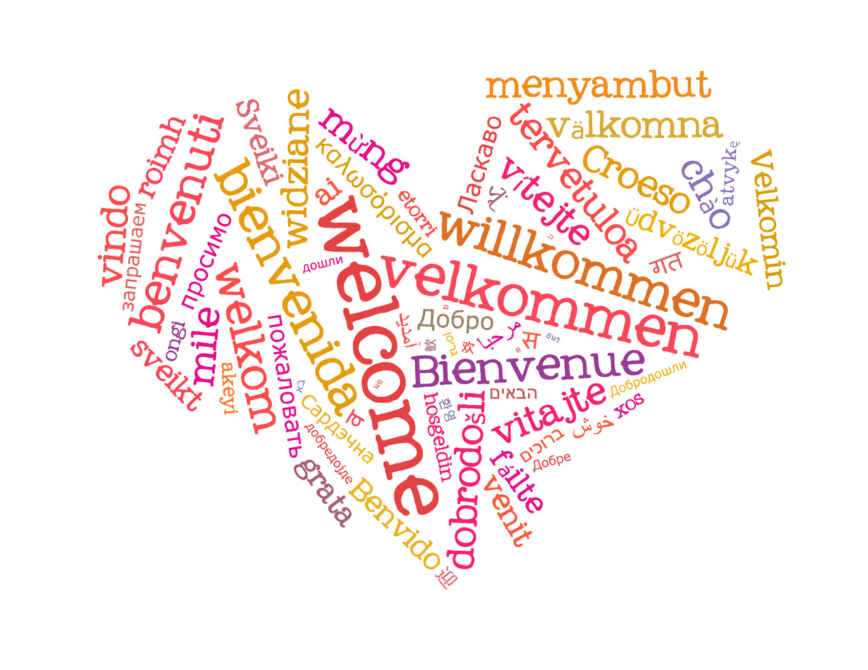
Welcome
Prelude: “Amazing Grace”
arr. Douglas Wagner

Call to Worship The Doxology
♪ Praise God, from whom all blessings flow; Praise *Him, all creatures here below; Praise *Him above, ye heavenly host; Praise Father, Son, and Holy Ghost. Amen.

“How Great Thou Art! “
Red Praise No. 16

Confession:
Holy and merciful God, in Your presence we confess our failure to be what You created us to be. You alone know how often we have sinned in wandering from Your ways, in wasting Your gifts, in forgetting Your love. By Your loving mercy, help us to live in Your light and abide in Your ways, for the sake of Jesus Christ our Savior.

[silent prayer & reflection; let the Holy Spirit identify any sin that needs confessing - offer it to God & let it go]
Assurance of Pardon & Gloria Patri (Blue No. 579)

Glory be to the Father, and to the Son, and to the Holy Ghost. As it was in the beginning, is now, and ever shall be, world without end. Amen. Amen

