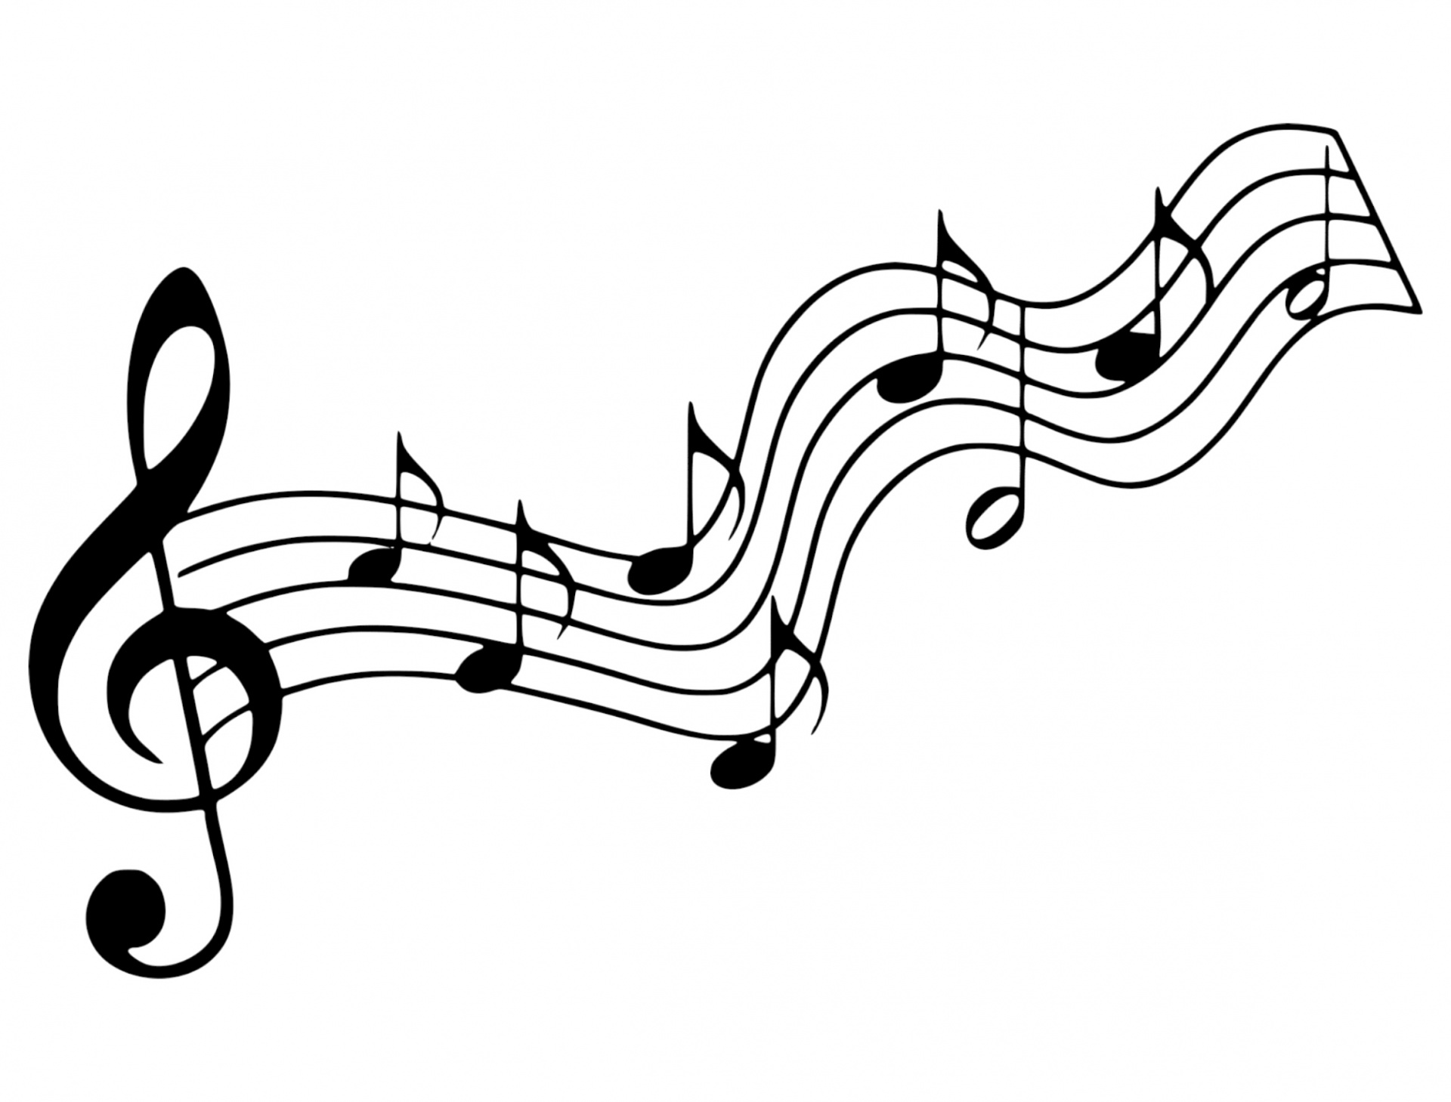

“O Most High” Weber
I will praise You, O Lord, with my whole heart!
I will tell of all Your marvelous works!
I will be glad and rejoice in You.
I will sing praise to Your name, O Most High!

O Most High! O Most High!
I will sing praise to Your Name,
O Most High!

Scripture Acts 9:36-43 (p.1565)

Faith Engagement and Sermon
“Because He Lives” No. 238
(Red Praise)

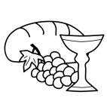Communion
Prayers of the Pastor & the People
With Praise & Thanksgiving
share briefly names & situations to lift to God in prayer -- we know God is more than able to hold
all we offer & God knows the details!
Lord in Your mercy...Hear our prayer!

Blessing “Halle, Halle, Halle-lujah (X3)
Hallelujah, Hal-le-lu-jah!”

Personal Milestones

May 14- Ann Weber

Prayer Concerns:
Prayer family: Yoko and Emily vonBorstel
Prayer young person: Eve Golden
Prayer theme for young adults: friends
All medical professionals, emergency responders & those serving
in hospitals, nursing homes & care facilities
Military folks & family - the USA & all those in leadership
S-VE School Board members, administrators, teachers & others
North Spencer Christian Academy
Church Finances
Samaritan’s Purse
Spencer Federated Church – Pastor Delma West

Announcements/Reminders:
A note about offering - all we have is a gift from God. We are invited weekly (and honestly at all times)to respond to God & joyfully give some of what we’ve been trusted with. For financial giving please place in an offering plate when arriving/leaving or mail to:
- Danby Rd, Spencer NY 14883 -OR- PO Box 367, Spencer, NY. 14883

Calendar

Monday -- 6PM AA
Wednesday -- Men's Breakfast & Bible Study
Wednesday -- 11AM Adult Study
Wednesday -- 6:30PM PTO mtg
Friday -- 11AM Women's Bible Study
Sunday – 10 AM Adult Study
11 AM Worship

Communion Liturgy:
Eat this Bread *Communaute de Taize, adapted by Robert J. Batastini (1984)

Eat this bread, drink this cup, Come to me and never be hungry. Eat this bread, drink this cup, Trust in me and you will not thirst.
The LORD be with you. And also with you. Lift up your hearts. We lift them to the LORD. Let us give thanks to the LORD our God. It is right to give our thanks and praise!
(prayer of thanksgiving & praise -- ending with the LORD's prayer)

...he took bread & after giving thanks to God he broke it & gave it to his disciples saying, "Take, eat. This is my body given for you.
Do this in remembrance of me."

And in the same way Jesus took the cup, saying:
"This cup is the new covenant sealed in my blood, shed for you for the forgiveness of sins. Whenever you drink it, do this in remembrance of me."

All who trust in Jesus Christ as Lord are welcome. As you receive the sacrament of communion consider the grace of what Jesus has done for us all and how much God loves you. After all receive, we pray:

God, thank You for accepting us as living members of Your Son & our Savior Jesus Christ. Thank you for feeding us with spiritual food in the Sacrament of his body and blood. Send us into the world in peace, granting us strength and courage to love and serve You with gladness and singleness of heart; through Christ our Lord.

3-fold Amen. (Amen, Amen, Amen!)

Christ the King Fellowship
Presbyterian #love
May 8, 2022 - 11 AM

Welcome
Prelude: “A Joyous Acclamation ”
Lani Smith
Call to Worship The Doxology
♪ Praise God, from whom all blessings flow; Praise
*Him, all creatures here below; Praise *Him above, ye heavenly host; Praise Father, Son, and Holy Ghost. Amen.

“Christ Is Risen! Shout Hosanna! “
(Blue Hymnal) No. 104

Confession:
Holy and merciful God, in Your presence we confess our failure to be what You created us to be. You alone know how often we have sinned in wandering from
Your ways, in wasting Your gifts, in forgetting Your love. By Your loving mercy, help us to live in Your light and abide in Your ways, for the sake of Jesus
Christ our Savior.
[silent prayer & reflection; let the Holy Spirit identify any sin that needs confessing - offer it to God & let it go]

Assurance of Pardon & Gloria Patri

Glory be to the Father, and to the Son, and to the Holy Ghost. As it was in the beginning, is now, and ever shall be, world without end. Amen. Amen
(Blue No. 579)

