Scripture 1: Luke 15:1-10 (p. 1489)
Scripture 2: 1 Timothy 1:12-17 (p. 1689)

Faith and Engagement

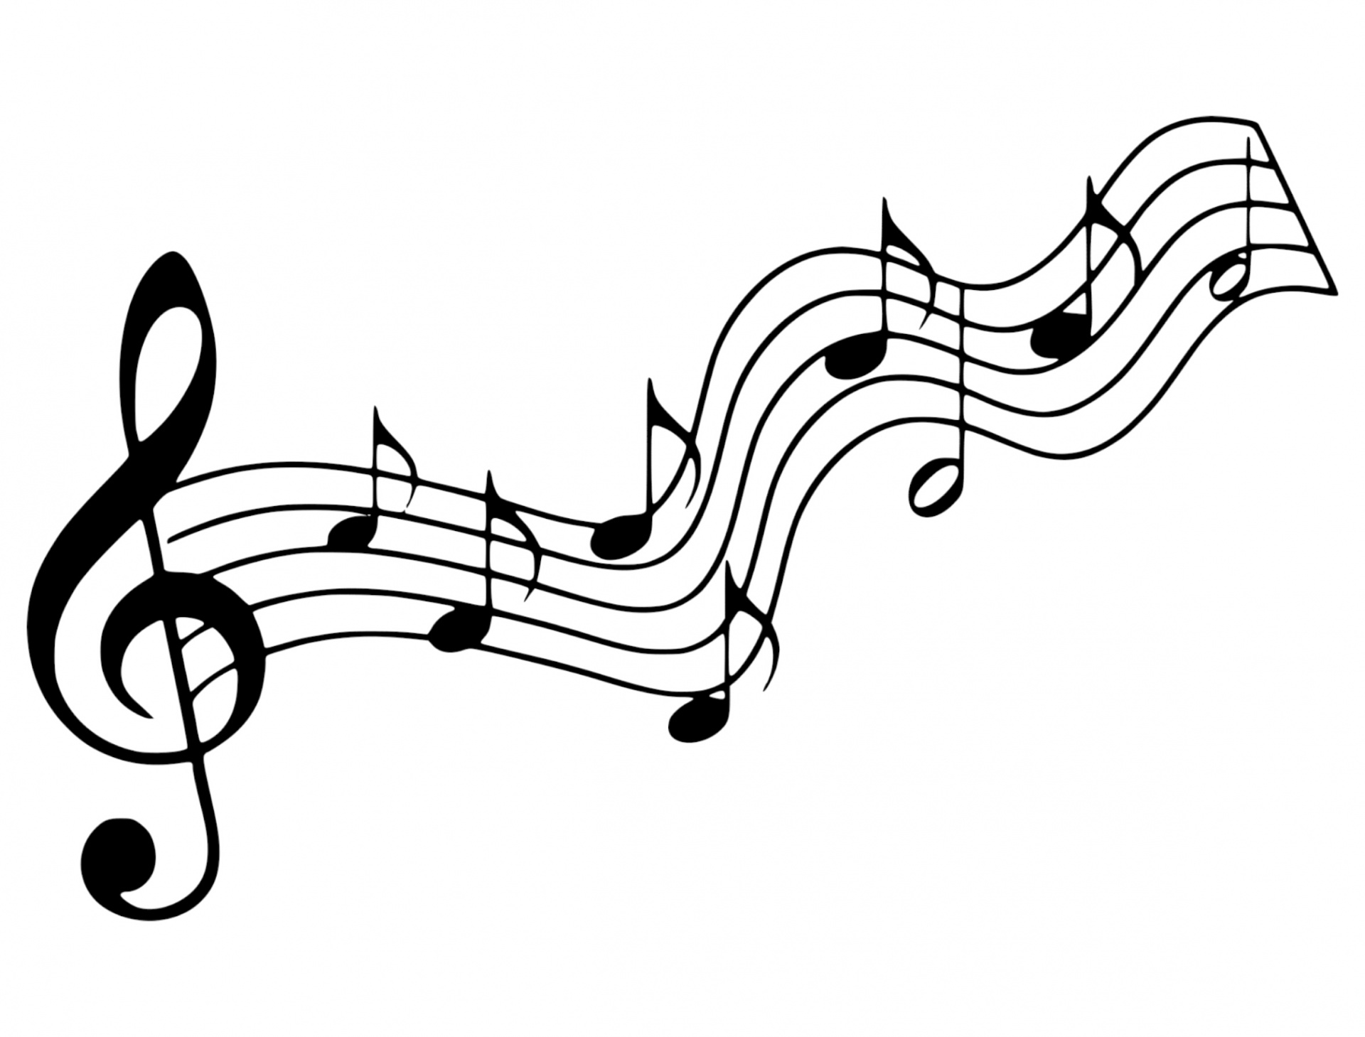
“I Come with Joy” No.507
(Blue Hymnal)

Communion
Prayers of the Pastor & the People
With Praise & Thanksgiving
share briefly names & situations to lift to God in prayer – we know God is more than able to hold all we offer & God knows the details! Lord in Your mercy…Hear our prayer!
Blessing “Halle, Halle, Halle-lujah (X3)
Hallelujah, Hal-le-lu-jah!”

Prayer Concerns:
Prayer family: Ann Weber and John Piechota
Prayer young person: Erzsi Helmetsie
Prayer theme for young adults: faith
All medical professionals, emergency responders & those serving
in hospitals, nursing homes & care facilities
Military folks & family - the USA & all those in leadership
S-VE School Board members, administrators, teachers & others
North Spencer Christian Academy
Church Finances
Empowering Lives
United Methodist Church of Halsey Valley

Announcements/Reminders:
A note about offering - all we have is a gift from God. We are invited weekly (and honestly at all times)to respond to God & joyfully give some of what we’ve been trusted with. For financial giving please place in an offering plate when arriving/leaving or mail to:
- Danby Rd, Spencer NY 14883 -OR- PO Box 367, Spencer, NY. 14883

Calendar

Monday -- 3PM Session Mtg
Monday -- 6PM AA
Friday -- 11AM Women's Bible Study
Sunday -- 10AM Adult Study -- 11AM Worship

Organ Concert & Singing - Sept. 25th @ 4PM

Communion Liturgy:

Eat this Bread *Communaute de Taize, adapted by Robert J. Batastini (1984)

Eat this bread, drink this cup, Come to me and never be hungry. Eat this bread, drink this cup, Trust in me and you will not thirst.
The LORD be with you. And also with you. Lift up your hearts. We lift them to the LORD. Let us give thanks to the LORD our God. It is right to give our thanks and praise!
(prayer of thanksgiving & praise -- ending with the LORD's prayer)

...he took bread & after giving thanks to God he broke it & gave it to his disciples saying, "Take, eat. This is my body given for you.
Do this in remembrance of me."

And in the same way Jesus took the cup, saying:
"This cup is the new covenant sealed in my blood, shed for you for the forgiveness of sins. Whenever you drink it, do this in remembrance of me."

All who trust in Jesus Christ as Lord are welcome. As you receive the sacrament of communion consider the grace of what Jesus has done for us all and how much God loves you. After all receive, we pray:

God, thank You for accepting us as living members of Your Son & our Savior Jesus Christ. Thank you for feeding us with spiritual food in the Sacrament of his body and blood. Send us into the world in peace, granting us strength and courage to love and serve You with gladness and singleness of heart; through Christ our Lord.

3-fold Amen. (Amen, Amen, Amen!)

Christ the King Fellowship
Presbyterian #love
September 11, 2022 - 10 AM
Welcome

Prelude: “Let Us Break Bread Together”
arr. Harold DeCou

Call to Worship The Doxology
♪ Praise God, from whom all blessings flow; Praise *Him, all creatures here below; Praise *Him above, ye heavenly host; Praise Father, Son, and Holy Ghost. Amen.
(Blue Hymnal No. 592)

“Joyful, Joyful, We Adore Thee” No. 53
(Red Praise)
Confession (Book of Common Worship)
Almighty God, You poured Your Spirit upon gathered disciples creating bold tongues, open ears, and a new community of faith. We confess that we hold back the force of Your Spirit among us. We do not listen for Your word of grace, speak the good news of Your love, or live as a people made one in Christ. Have mercy on us, O God. Transform our timid lives by the power of Your Spirit, and fill us with a flaming desire to be Your faithful people, doing Your will for the sake of Jesus Christ our Lord.

[silent prayer & reflection; let the Holy Spirit identify any sin that needs confessing - offer it to God & let it go]

Assurance of Pardon & Gloria Patri
Glory be to the Father, and to the Son, and to the Holy Ghost. As it was in the beginning, is now, and
ever shall be, world without end. Amen. Amen
(Blue No. 579)

