

**“Give Thanks”** Henry Smith

Give thanks with a grateful heart,  
give thanks to the Holy One;  
 give thanks because he’s given Jesus Christ, his  
 Son. (Repeat)

And now let the weak say,“We are strong!”  
 Let the poor say,“We are rich  
 because of what the Lord has done for us!” (Repeat)

Give thanks.  
 Give thanks.

“Lord, Listen to Your Children Praying” Ken Medema

 Lord, listen to your children praying,  
 Lord, send your Spirit in this place;  
 Lord, listen to your children praying.  
 Send us love, send us pow’r, send us grace.

*Repeat*

Scripture 1: 1 Timothy 2:1-7

Scripture 2: Jeremiah 8:18-9:1

 Faith and Engagement

**“There Is a Balm in Gilead”**  No.394

**(**Blue Hymnal**)**



Prayers of the Pastor & the People

With Praise & Thanksgiving

*share briefly names & situations to lift to God in prayer – we know God is more than able to hold all we offer & God knows the details!*  Lord in Your mercy…**Hear our prayer!**

Blessing **“Halle, Halle, Halle-lujah (X3)**

**Hallelujah, Hal-le-lu-jah!”**

**PERSONAL MILESTONES**

**September 19- Runningbrook Crowley**

**September 20 – Doris Barber**

**September 22- Susan Garrison**

**Prayer Concerns:**

Prayer family:  **Ralph and Ellie Cobb**

Prayer young person: **Jacob Bailey**

Prayer theme for young adults: **faith**

All medical professionals, emergency responders & those serving

in hospitals, nursing homes & care facilities

Military folks & family - the USA & all those in leadership

S-VE School Board members, administrators, teachers & others

North Spencer Christian Academy

Church Finances

Samaritan’s Purse

Bible Baptist of West Danby – Pastor Seth Finch

**Announcements/Reminders:**

***A note about offering*** - all we have is a gift from God.  We are invited weekly (and honestly at all times)to respond to God & joyfully give some of what we’ve been trusted with.  For financial giving please place in an offering plate when arriving/leaving or mail to:

1. *Danby Rd, Spencer NY 14883 -OR- PO Box 367, Spencer, NY. 14883*

**Calendar**

Friday -- 11AM Women's Bible Study

Sunday -- 10AM Adult Study 11AM Worship

Monday -- 6PM AA

Tuesday -- 3:30PM Healthy Living for Your Brain & Body

Wednesday -- 11AM Adult Study (Gen. 12-22)

Sunday - SEPT. 25th - Music Concert @ 4PM (Organ, Hymns - FUN!)

**Community Events:**

Mon. 6PM Candor Community Pottery Classes ($20) Candor High School Rm 220

Wed. 4-5PM Alpha @ Spencer Federated Church (Alpha presentation, discussion, prayer) -- all invited!

Wed. 4-5:30PM [Open Hearts Dinner @ Mckendree UMC **TAKE OUT ONLY](https://www.candormethodists.com/openheartsdinnermenu)**

3rd Fri. 11:30-12:30PM Sr. Social Hour @ Inspire RSVP @ 607-687-4120 [INFO](https://docs.google.com/presentation/d/1gSIDLegOBYXijkgk1MtT7Jeih2Hxc-qX37O6fkYDjZw/pub?start=false&loop=false&delayms=3000&slide=id.g152fbc6adfa_0_0)

Sat. 9AM-12:30PM SVE Farmer's Market! (in front of the Nichol's Pond)

**9/18**: 6PM  A special evening of song w/Wayne & Carole Beddoe @ McKendree Church (224 Owego Rd, Candor)

**9/19**: 10AM Story Hour @ Spencer Library

**9/19**: 7PM Spencer Historical Society Mtg @ Museum on Center Street

**9/20**: 3:30PM Healthy Living for Your Brain & Body (Presentation by Alzheimer's Association) @ CTK - 75 N. Main St.  (RSVP @ 607-687-4120)

**9/21**: 2-4PM National Preparedness Month - Protecting Places of Worship Webinar ([LINK/Regiser](https://fema.zoomgov.com/webinar/register/WN_7gJts4_zQJqOIq4k_raQ_w))

**9/22**:7PM SVE Board of Education Workshop mtg (@ Middle School Library).

**9/24**: 6-8PM Concert Celebrating the Town of Erin's 200 years!  @Erin United Methodist Church (52 Church Street Erin) [INFO](https://docs.google.com/presentation/d/1gSIDLegOBYXijkgk1MtT7Jeih2Hxc-qX37O6fkYDjZw/pub?start=false&loop=false&delayms=3000&slide=id.g152fbcc20fe_0_5)

**9/25**: 4PM Live Music Concert @ Christ The King by: Dave Jackson, Brenda Yeier & Jewell Griffith

**9/27**: 11AM-1PM Community Health Fair @ Tioga Downs [INFO](https://docs.google.com/presentation/d/1gSIDLegOBYXijkgk1MtT7Jeih2Hxc-qX37O6fkYDjZw/pub?start=false&loop=false&delayms=3000&slide=id.g152fbc6adfa_0_5)

**9/29**:  9-10:30AM  SVE Food Cupboard food give-away.  Both indoor (Masks worn & bring bags/boxes) shopping & pick-up options.  (Orchard St. near the "old" Dollar General; open to all who live or work in SVE School District)

**9/29**: 5:30PM Finding Balance in an Imbalanced World led by Sarah Mission @ Candor Free Library (Bank St. - also can livestream @ Align with Sarah YT channel).

Christ the King Fellowship

Presbyterian **#love**

**September 18, 2022 - 11 AM**

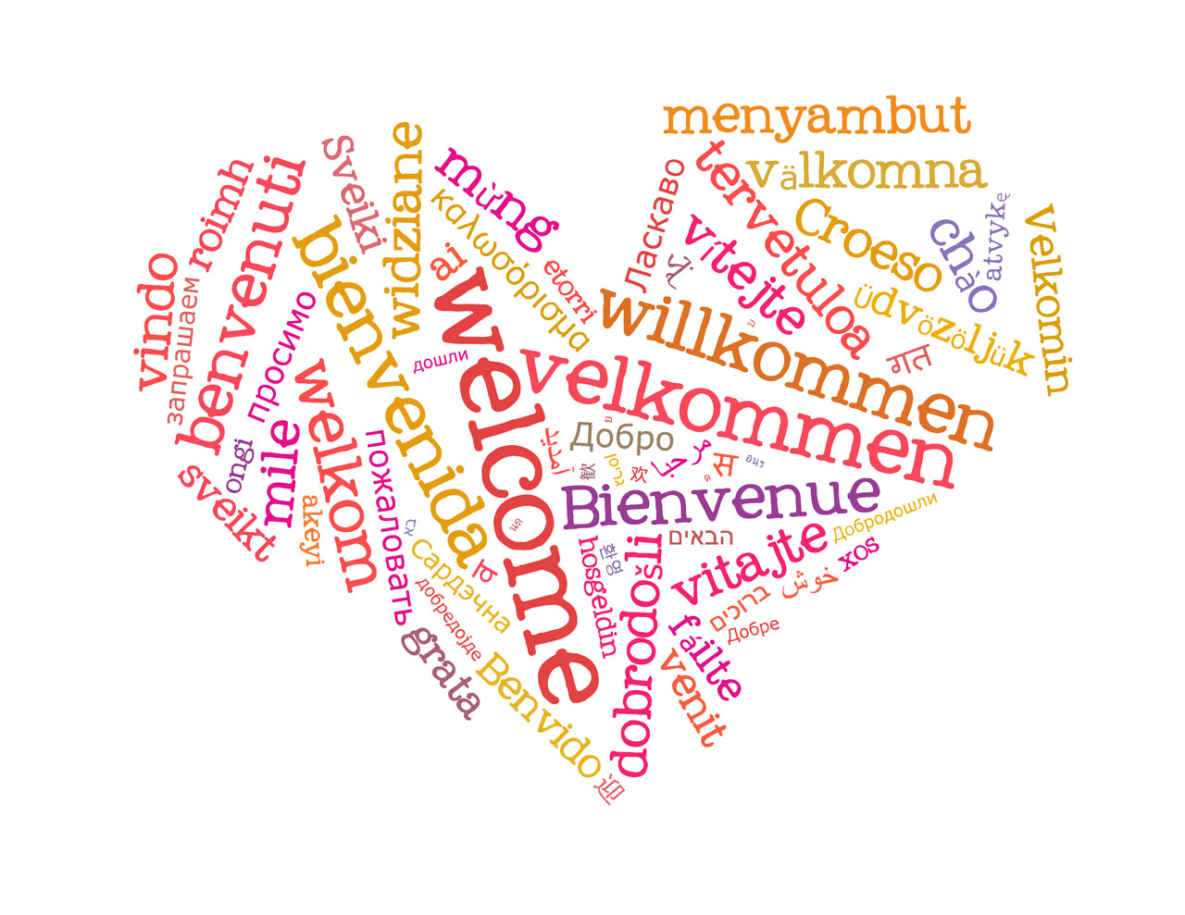

Welcome

Prelude “Processional In C” by Douglas Wagner

Call to Worship   The Doxology

**♪ Praise God, from whom all blessings flow; Praise *Him, all creatures here below; Praise *Him above, ye heavenly host; Praise Father, Son, and Holy Ghost. Amen.** (Blue Hymnal No. 592)



“Crown Him with Many Crowns**”** No. 151

(Blue Hymnal)

Confession (*The Service for the Lord's Day, SR1*)

Merciful God, we confess we have often failed to be an obedient church.  We have not done Your will, we have broken Your law, we have rebelled against Your love.  We have not loved our neighbors, and have refused to hear the cry of the needy.  Forgive us, and free us for joyful obedience; through Jesus Christ our Lord.

[*silent prayer & reflection; let the Holy Spirit identify any sin that needs confessing - offer it to God &* ***let it go***]

Assurance of Pardon **& Gloria Patri**

**Glory be to the Father, and to the Son, and to the Holy Ghost.  As it was in the beginning, is now, and**

**ever shall be, world without end. Amen. Amen**

**(Blue No. 579)**