“Give Thanks” P-1 Smith

Give thanks with a grateful heart,
Give thanks to the Holy One;
Give thanks because He’s given Jesus Christ, His Son.
(Repeat section)

And now let the weak say, “I am strong”,
Let the poor say, “I am rich
Because of what the Lord has done for us.”
Give thanks. (Repeat section)

“Have Thine Own Way”
Have Thine own way Lord
Have Thine own way
Thou art the potter I am the clay
Mold me and make me after Thy will
While I am waiting yielded and still

Choir “Our Thanks To Thee” - by Ann Weber

Scripture 1: Ezekiel 34:11-16; 20-24 (p.1236 )
Scripture 2: Matthew 25:31-46 (p 1415 )
Faith and Engagement
“Crown Him with Many Crowns “ No. 151
(Blue Hymnal)

Prayers of the Pastor and the People with Praise
Thanksgiving share briefly names & situations to lift to God in prayer – we know God is more than able to hold all we offer & God knows the details! Lord in Your mercy…Hear our prayer

Blessing
“Halle, Halle, Halle-lujah (X3)
Hallelujah, Hal-le-lu-jah!”

Personal Milestones
November 21- Marina Billot
November 22- Lori Maratea
November 24- Rick Dann
Patty and Gary Decker

Prayer Concerns
Prayer family: Tom and Gina Bailey
Prayer young person: Eve Golden
Prayer theme for young adults: faith
All medical professionals, emergency responders & those serving
in hospitals, nursing homes & care facilities
Military folks & family - the USA & all those in leadership
S-VE School Board members, administrators, teachers & others
North Spencer Christian Academy
Church Finances
Food Cupboard
Bible Baptist of North Spencer

Calendar
Sunday -- post worship Congregational Mtg (voting on Deacons/Elders)
Sunday -- post Congregational Mtg - Decorating (& eating!)
Monday -- 6PM AA
Tuesday -- No Pastor's Hours
Wednesday -- 11AM Adult Study
Sunday -- 10AM Adult Study & 11AM Worship

Announcements/Reminders:
A note about offering - all we have is a gift from God. We are invited weekly (and honestly at all times)to respond to God & joyfully give some of what we’ve been trusted with. For financial giving please place in an offering plate when arriving/leaving or mail to:
- Danby Rd, Spencer NY 14883 -OR- PO Box 367, Spencer, NY. 14883

Community Events:

Mon. 10AM Story Hour @ Spencer Library
Wed. 4-5:30PM Open Hearts Dinner @ Mckendree UMC **TAKE OUT ONLY**
3rd Thurs. 10-11:30AM Mom-to-Mom group @ Inspire (57 E. Tioga St, Spencer)
3rd Fri. 11:30-12:30PM Sr. Social Hour @ Inspire RSVP @ 607-687-4120 INFO
**Candor Events: Home (candornychamber.org)
11/23: 12noon Thanksgiving Day Dinner @ CTK
11/28: 11AM-6PM Doug's Fish Fry To-Go @ N. Spencer Christian Academy
11/30: 9-10:30AM Food Cupboard food give-away. Both indoor (bring bags/boxes) shopping & pick-up options. (Orchard St. near the "old" Dollar General; open to all who live or work in SVE School District)
12/3: 7PM Candor Community Chorus & Hymn Sing @ CTK (with cookies!)
12/4: 6PM Dangers of Social Media & How to Protect Your Children @ SVE HS Auditorium
12/6: 4-6PM Sr. Citizen Holiday Dinner @SVE HS (Hosted by SVE Sr. High Student Council) Free: RSVP: 607-589-7140

Library happenings:
@ Spencer Library
Non-perishables are available in the front entryway to the library (if you'd like to donate - donations can be received during open hours)
*** Story Hour Mondays @ 10AM ***

@ Van Etten Library (LINK for their website/hours/calendar)
Hours: Mon: 1-5PM; Wed & Fri: 11AM-1PM & 2PM-5PM

Christ the King Fellowship
Presbyterian #love
November 26, 2023 – 11:00 AM
Welcome
Prelude “Rejoice The Lord is King”
by Harold DeCou Call to Worship
I will bless the LORD at all times.
God's praise will always be in my mouth!
Taste and see that the LORD is good.
Happy are those who run to God!
(The Doxology)♪ Praise God, from whom all blessings flow; Praise *Him, all creatures here below; Praise *Him above, ye heavenly host; Praise Father,
Son, and Holy Ghost. Amen (Blue Hymnal No. 592)

“He Is King of Kings“ No. 153
(Blue Hymnal)
Confession (from BCW)

Holy and merciful God, in Your presence we confess our failure to be what You created us to be.
You alone know how often we have sinned in
wandering from Your ways, in wasting Your gifts,
in forgetting Your love. By your loving mercy,
help us to live in Your light and abide in Your
ways, For the sake of Jesus Christ our Savior.
[silent prayer & reflection; let the Holy Spirit identify
any sin that needs confessing - offer it to God & let it go]
Assurance of Pardon & Gloria Patri
Glory be to the Father, and to the Son, and to the Holy Ghost. As it was in the beginning, is now, and ever shall be, world without end. Amen. Amen
(Blue No. 579)

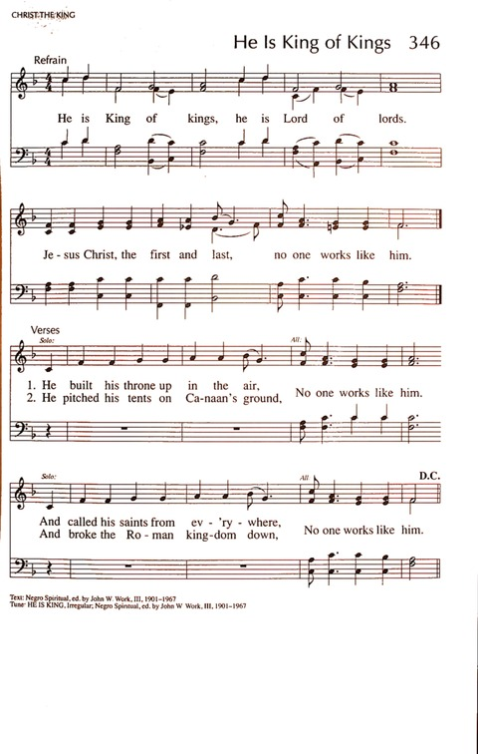

“Crown Him with Many Crowns” Matthew Bridges
Crown him with many crowns,
The Lamb upon his throne;
Hark! how the heav'nly anthem drowns
All music but its own:
Awake, my soul, and sing
Of him who died for thee,
And hail him as thy matchless King
Through all eternity.
Crown him the Lord of love;
Behold his hands and side,
Rich wounds, yet visible above,
In beauty glorified:
No angel in the sky
Can fully bear that sight,
But downward bends his burning eye
At mysteries so bright.
Crown him the Lord of peace;
Whose pow'r a scepter sways
From pole to pole, that wars may cease,
Absorbed in prayer and praise:
His reign shall know no end;
And round his pierced feet
Fair flowers of Paradise extend
Their fragrance ever sweet.
Crown him the Lord of years,
The Potentate of time;
Creator of the rolling spheres,
Ineffably sublime:
All hail, Redeemer, hail!
For thou hast died for me:
Thy praise shall never, never fail
Throughout eternity.

