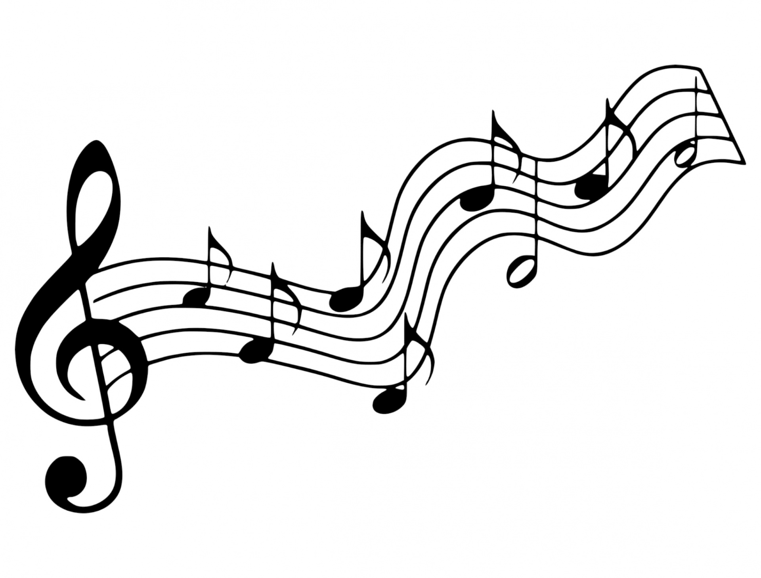
Christmas Carols

Scripture James 5:13-18 (p. 1725 )

Faith and Engagement
“What Child is This ” No. 53
(Blue Hymnal)

Prayers of the Pastor and the People with Praise
Thanksgiving share briefly names & situations to lift to God in prayer – we know God is more than able to hold all we offer & God knows the details! Lord in Your mercy…Hear our prayer

Blessing

“Halle, Halle, Halle-lujah (X3)
Hallelujah, Hal-le-lu-jah!”

Personal Milestones
December 31- Marvin Fisher
January 1- Ralph and Ellie Cobb

Prayer Concerns
Prayer person: David Lanning
Prayer young person: Ethan Drake
Prayer theme for young adults: friends
All medical professionals, emergency responders & those serving
in hospitals, nursing homes & care facilities
Military folks & family - the USA & all those in leadership
S-VE School Board members, administrators, teachers & others
North Spencer Christian Academy
Church Finances
Samaritan’s Purse
Van Etten Assembly of God

Announcements/Reminders:
A note about offering - all we have is a gift from God. We are invited weekly (and honestly at all times)to respond to God & joyfully give some of what we’ve been trusted with. For financial giving please place in an offering plate when arriving/leaving or mail to:
- Danby Rd, Spencer NY 14883 -OR- PO Box 367, Spencer, NY. 14883

Community Events:
Mon. 10AM Story Hour @ Spencer Library
Wed. 4-5:30PM Open Hearts Dinner @ Mckendree UMC **TAKE OUT ONLY**
3rd Thurs. 10-11:30AM Mom-to-Mom group @ Inspire (57 E. Tioga St, Spencer)
3rd Fri. 11:30-12:30PM Sr. Social Hour @ Inspire RSVP @ 607-687-4120 INFO
**Candor Events: Home (candornychamber.org)
)

@ Spencer Library
Non-perishables are available in the front entryway to the library (if you'd like to donate - donations can be received during open hours)
*** Story Hour Mondays @ 10AM ***

@ Van Etten Library (LINK for their website/hours/calendar)
Hours: Mon: 1-5PM; Wed & Fri: 11AM-1PM & 2PM-5PM

Christ the King Fellowship
Presbyterian #love
December 31, 2023 – 11:00 AM
Welcome
Prelude “What Child is This?
arr by Richard Purvis

Call to Worship (Jer. 33:14):
The day of the LORD is surely coming: the promise
(The Doxology)♪ Praise God, from whom all blessings flow; Praise *Him, all creatures here below; Praise *Him above, ye heavenly host; Praise Father, Son, and Holy Ghost. Amen (Blue Hymnal No. 592)

“Angels from the Realms of Glory” No. 2
(Blue Hymnal )

Confession (from BCW) God of the future, You are coming in power to bring all nations under Your rule. We confess we have not expected Your kingdom, for we live casual lives, ignoring Your promised judgement. We accept lies as truth, exploit neighbors, abuse the earth, & refuse Your justice and peace. Forgive us. Turn us to Your will by the power of Your Spirit, so all may know Your justice & peace; through Jesus Christ, Your Son, our Savior.
[silent prayer & reflection; let the Holy Spirit identify
any sin that needs confessing - offer it to God & let it go]

Assurance of Pardon & Gloria Patri

Glory be to the Father, and to the Son, and to the Holy Ghost. As it was in the beginning, is now, and ever shall be, world without end. Amen. Amen
(Blue No. 579)

“Angels from the Realms of Glory” James Montgomery
- Angels from the realms of glory,
Wing your flight o’er all the earth;
Ye who sang creation’s story
Now proclaim Messiah’s birth.
  - Refrain:
Come and worship, come and worship,
Worship Christ, the newborn King.
- Shepherds, in the field abiding,
Watching o’er your flocks by night,
God with us is now residing;
Yonder shines the infant light:
- Sages, leave your contemplations,
Brighter visions beam afar;
Seek the great Desire of nations;
Ye have seen His natal star.
- All creation, join in praising
God, the Father, Spirit, Son,
Evermore your voices raising
To th’eternal Three in One.

“What Child is This” William Chatterton Dix
1 What Child is this, who, laid to rest,
On Mary's lap is sleeping?
Whom angels greet with anthems sweet,
While shepherds watch are keeping?
Chorus:
This, this is Christ, the King,
Whom shepherds guard and angels sing:
Haste, haste to bring Him laud,
The Babe, the Son of Mary!
2 Why lies He in such mean estate,
Where ox and ass are feeding?
Good Christian, fear: for sinners here
The silent Word is pleading.[Chorus]
3 So bring Him incense, gold, and myrrh,
Come, peasant, king to own Him.
The King of kings salvation brings;
Let loving hearts enthrone Him.[Chorus]

