As We Walked Home
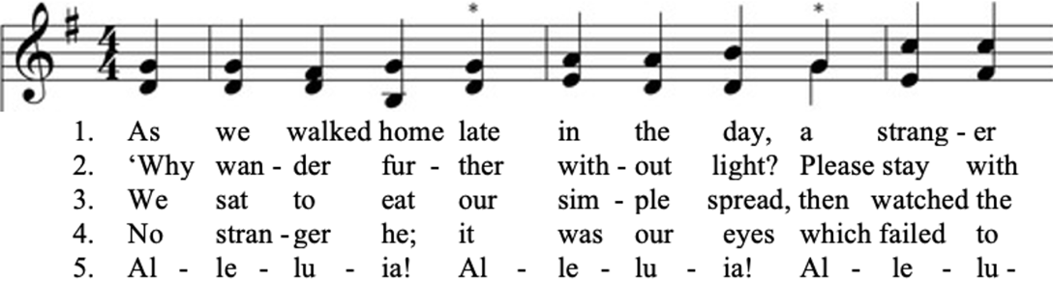

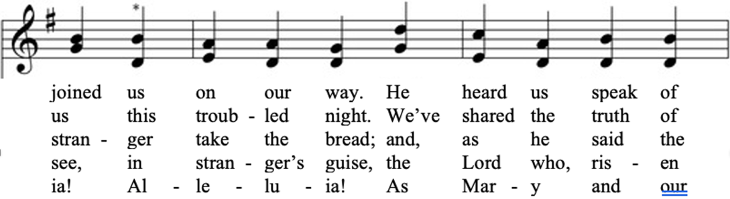

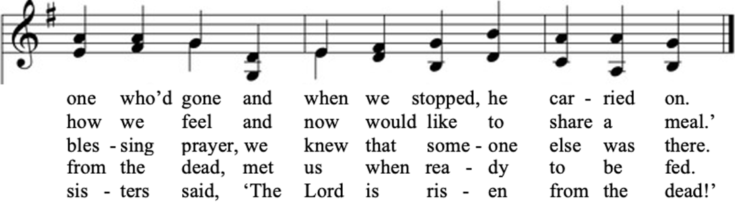

Music: Tallis’ Canon Words: Wild Goose Worship Group

Calendar

Monday -- 6PM AA
Tuesday -- 3-5PM Art Group All are welcome! Come on out! (also...come early for Creative Writing @ 2PM)
Wednesday -- 6AM Men's Bible Study
Wednesday -- 11AM Adult Study
Thursday --
Friday -- 11AM Women's Bible Study
Friday --
Saturday --
Friday -- 11AM Women's Bible Study
Sunday -- 10AM Adult Study| 11AM Worship

Christ the King Fellowship
Presbyterian #love
April 19, 2026 – 11:00 AM

Welcome
Prelude
Call to Worship
Jesus Christ, you meet us with the face of a stranger
but your breath is warm
and your conversation engaging.
Death has not changed your accent
or diminished your love.
And though the world still shows signs of imperfection,
the good news is that you have destined it
and all its people to be made whole.
So, since in this Eastertide we are gathered in your house,
and cheered by your gospel.
Join us, as you joined your first disciples
and make this worship our Emmaus road.


“The Doxology” No. 592
“Christ Is Risen” No. 109
(Blue Hymnal)

Confession
Let us pray.
Risen Christ Jesus,
despite our Eastertide declarations,
we feel your absence keenly.
We look for you to intervene in wars and injustice.
Yet we fail to recognize you in our daily lives;
saving, healing and restoring hope to the hopeless.
We become cynical
thinking your promise of resurrection
is strictly metaphorical,
We fear living a death-defying life in your Spirit.
Ever-living Christ,
show yourself to us again and again.
Let us experience your faithfulness in spring’s witness
to life’s glorious return.
Join us with disciples of every age in Christ’s Spirit,
and let us see your living body among us.

Assurance of Pardon
“The Strife is O’er” No. 119
(Blue Hymnal) Vss. 1 & 2

Christ’s death-defying life is the source of salvation.
Let us live the saving life Christ Jesus has shown us.

Scripture Readings

Hebrew Scripture: Isaiah 51:1-6 (p.1049)

Gospel: Luke 24:13-35 (p. 1507)

Faith and Engagement
“As We Walked Home“
(see back page of bulletin)

Prayers of the People with Praise and Thanksgiving
Share briefly names & situations to lift to God in prayer –
we know God is more than able to hold all we offer
& God knows the details!
…Lord in Your mercy
Hear our prayer.

Let us pray as Jesus taught his disciples:
Our Father in heaven, hallowed be your name.
Your kingdom come,
your will be done on earth as it is in heaven.
Give us today our daily bread.
Forgive us our sins
as we forgive those who sin against us.
Save us from the time of trial,
and deliver us from evil.
For the kingdom, the power, and the glory are yours,
now and forever. Amen.

“Christ Is Alive” No. 108
(Blue Hymnal)

Closing Sentences
Today and tomorrow.
The risen Christ says, “I am with you always.”
When our hopes are challenged by doubt.
God says, “I am with you always.”
When we walk life’s roads puzzled and despairing.
The Spirit says, “I am with you always.”
When we meet someone we don’t recognize.
Christ Jesus says, “I am with you always.”
When we share with friend and stranger.
The risen Christ says, “I am with you always.”
And should we forget…
We say, “Today and tomorrow, you, Christ,
are always with us to the end of the world.

Charge & Blessing
May Christ,
crucified and risen to ascend sideways into the world; clothe us with power to work in your Spirit,
equip us for mission, gift us with insight,
grant us compassion and steel us for challenge.
By the power of the Spirit, may we, Christ’s living body,
follow Jesus’ ways today and every day.

Prayer Concerns
Prayer family: Kerm and Carol Bossard
Prayer young person: Ariyah Dutra
Prayer theme for young adults: Faith
All medical professionals, emergency responders & those serving in hospitals, nursing homes & care facilities
Military folks & family - the USA & all those in leadership
S-VE School Board members, administrators, teachers & others
North Spencer Christian Academy
Church Finances
Samaritan’s Purse
Personnel/ Nominating Committee
Halsey Valley Church

“Christ Is Risen” Charles Wesley
1 Christ the Lord is risen today, Alleluia!
Earth and heaven in chorus say, Alleluia!
Raise your joys and triumphs high, Alleluia!
Sing, ye heavens, and earth reply, Alleluia!
2 Lives again our glorious King, Alleluia!
Where, O death, is now thy sting? Alleluia!
Once he died our souls to save, Alleluia!
Where's thy victory, boasting grave? Alleluia!
3 Love's redeeming work is done, Alleluia!
Fought the fight, the battle won, Alleluia!
Death in vain forbids him rise, Alleluia!
Christ has opened paradise, Alleluia!

“The Strife is O’er” Francis Pott

1 The strife is o'er, the battle done;
the victory of life is won;
the song of triumph has begun.
Alleluia!
2 The powers of death have done their worst,
but Christ their legions has dispersed.
Let shouts of holy joy outburst.
Alleluia!
3 The three sad days are quickly sped;
he rises glorious from the dead.
All glory to our risen Head.
Alleluia!
4 He closed the yawning gates of hell;
the bars from heaven's high portals fell.
Let hymns of praise his triumph tell.
Alleluia!
5 Lord, by the stripes which wounded thee,
from death's dread sting thy servants free,
that we may live and sing to thee.
Alleluia!

“Christ Is Alive” Brian Wren

1. Christ is alive! Let Christians sing.
The cross stands empty to the sky.
Let streets and homes with praises ring.
Love, drowned in death, shall never die.

2. Christ is alive! No longer bound
to distant years in Palestine,
but saving, healing, here and now,
and touching ev’ry place and time.

3. In ev’ry insult, rift, and war,
where color, scorn, or wealth divide,
Christ suffers still, yet loves the more,
and lives, where even hope has died.

4. Christ is alive, and comes to bring
good news to this and ev’ry age,
till earth and sky and ocean ring
with joy, with justice, love, and praise.

